# QA

Q:

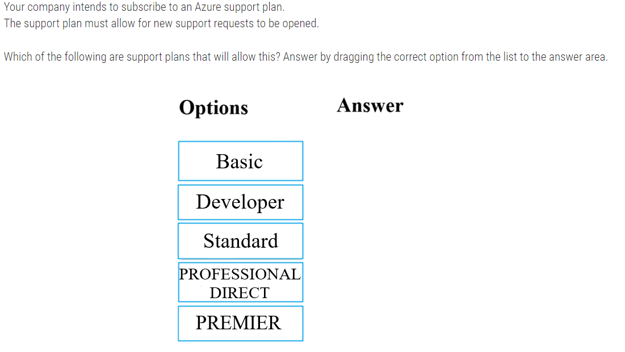

A:

Premier support exists but only for Enterprise

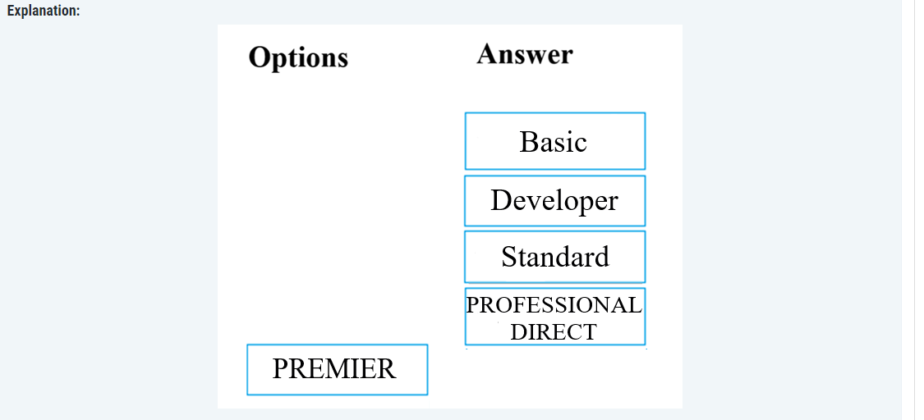

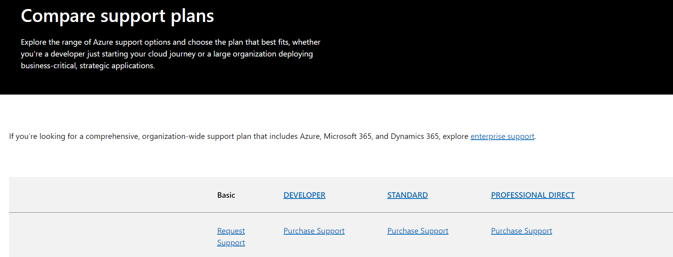

## 

Q: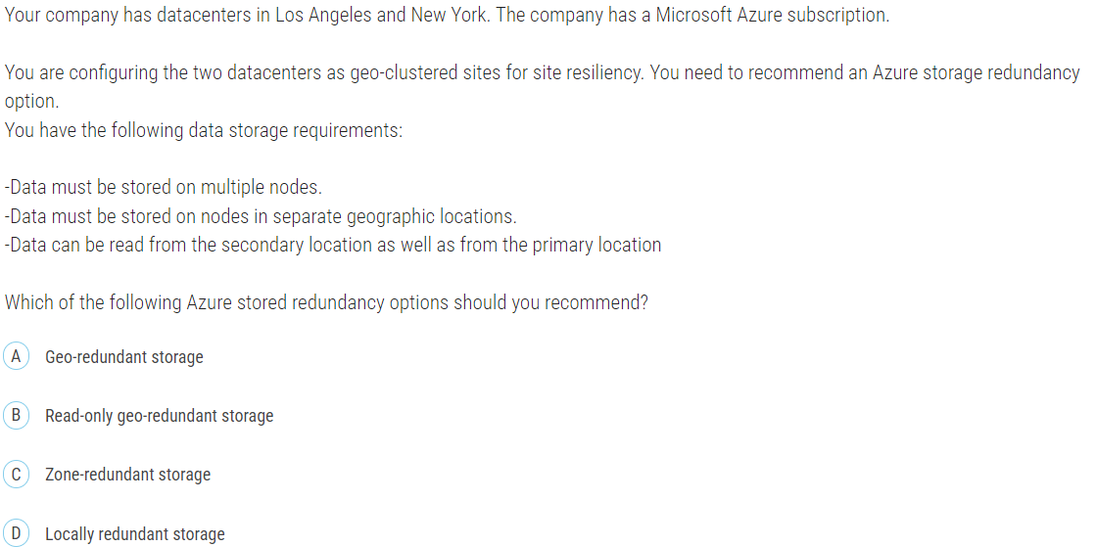

A:

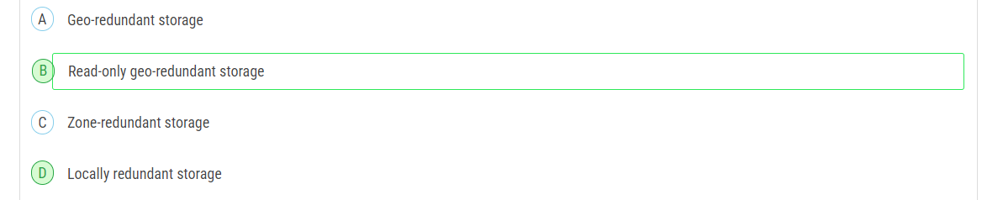

To meet the requirements of storing data on multiple nodes, across separate geographic locations, and allowing data to be read from the secondary location as well as from the primary location, you should recommend Read-access geo-redundant storage (RA-GRS).

Here's a breakdown of why RA-GRS is the best fit:

Data must be stored on multiple nodes: RA-GRS replicates data to multiple nodes within the primary region and to another region.

Data must be stored on nodes in separate geographic locations: RA-GRS replicates data to a secondary region, which is geographically distant from the primary region.

Data can be read from the secondary location as well as from the primary location: RA-GRS allows read access to the data in the secondary region, providing the capability to read from both the primary and secondary locations.

The other options do not fully meet the requirements:

Geo-redundant storage (GRS): While it stores data in multiple geographic locations, it does not provide read access to the secondary location.

Zone-redundant storage (ZRS): It stores data across different availability zones within the same region, not across separate geographic locations.

Locally redundant storage (LRS): It stores data within a single data center, not across multiple nodes or geographic locations.

Therefore, the recommended Azure storage redundancy option is Read-access geo-redundant storage (RA-GRS).

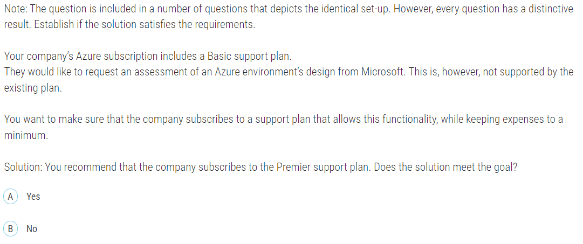

A: No, the solution does not meet the goal if the intention is to keep expenses to a minimum.

Q:

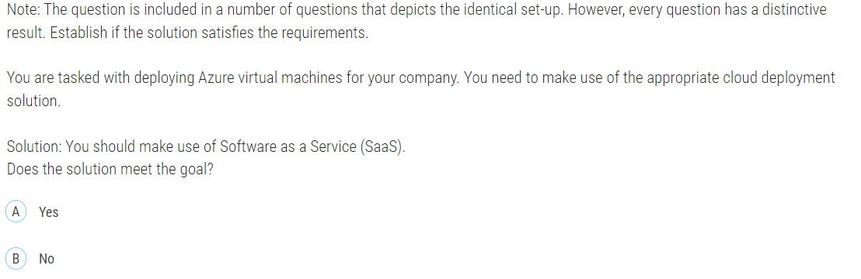

A: No, the solution does not meet the goal.

Deploying Azure virtual machines (VMs) falls under Infrastructure as a Service (IaaS), not Software as a Service (SaaS).

## 5.

Q:

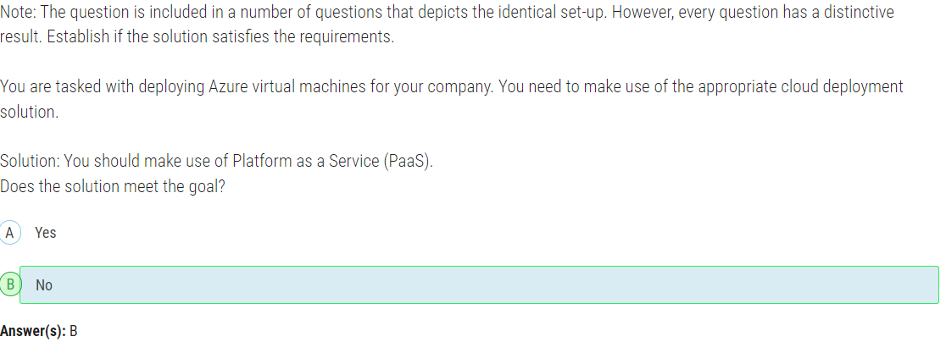

## 6.

Q:

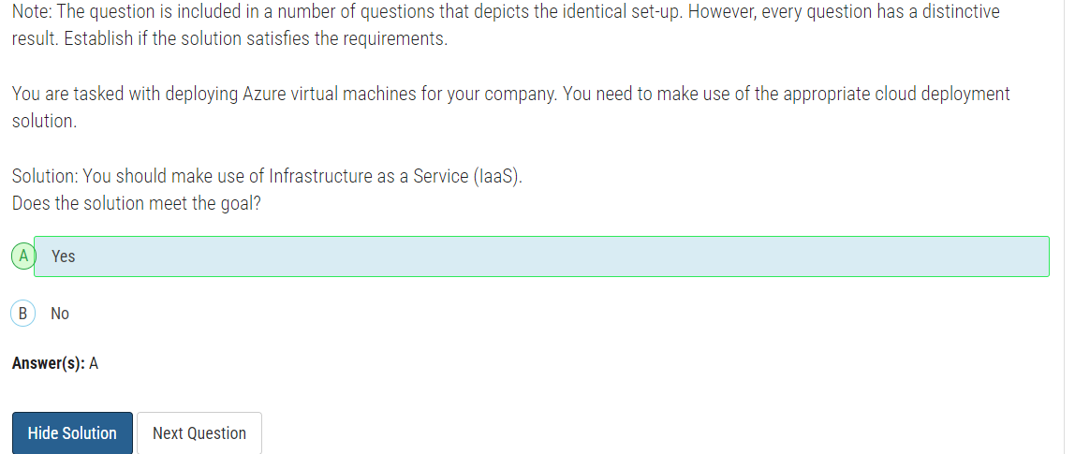

## 7.

Q:

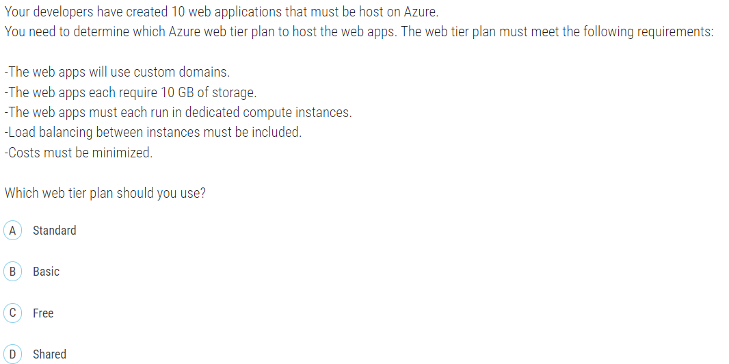

A:

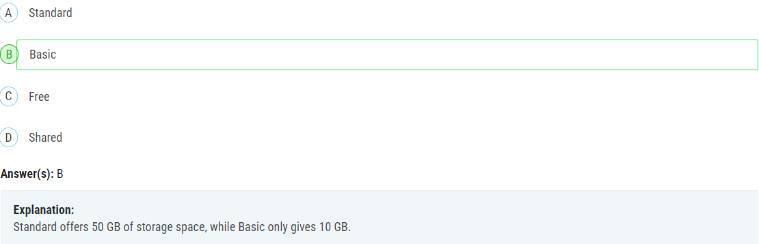

## 8.

Q:

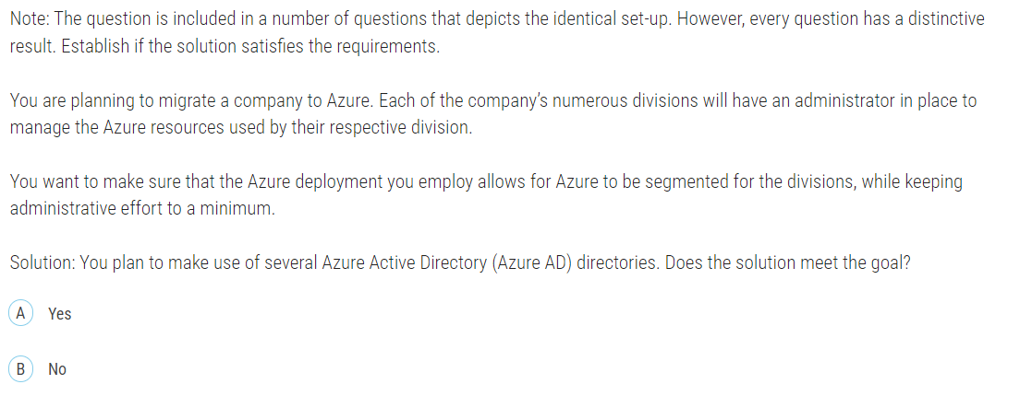

A: No, the solution does not meet the goal.

Using several Azure Active Directory (Azure AD) directories is not the optimal way to segment the company's Azure resources by division and keep administrative effort to a minimum. Managing multiple Azure AD directories would increase administrative complexity rather than minimize it.

A better approach is to use a single Azure AD directory and organize resources within that directory using **management groups**, **subscriptions**, and **resource groups**. This allows you to segment resources by division while maintaining a centralized management structure.

## 9.

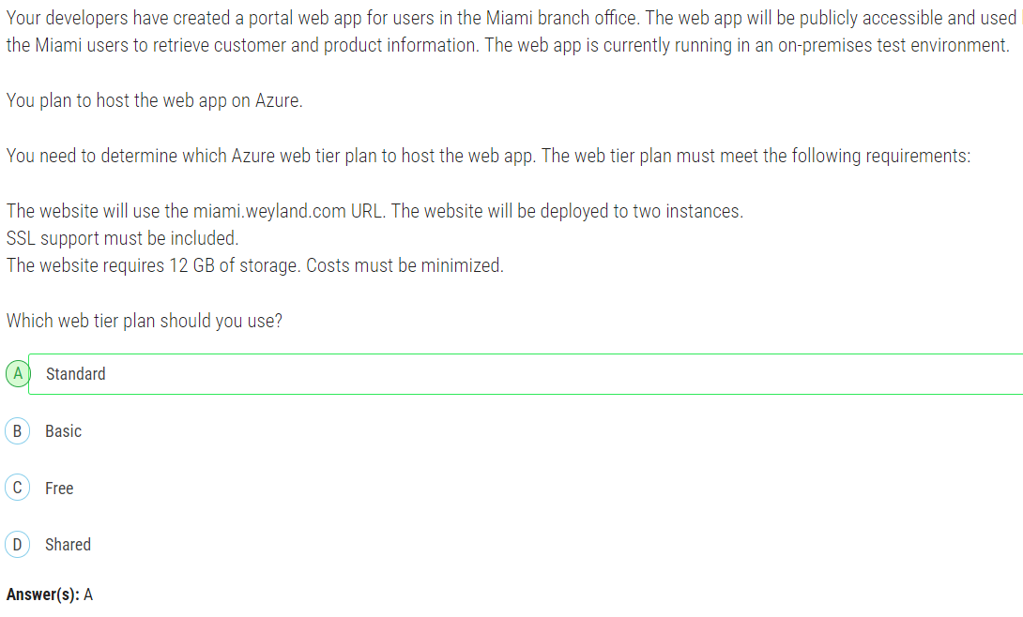

## 10.

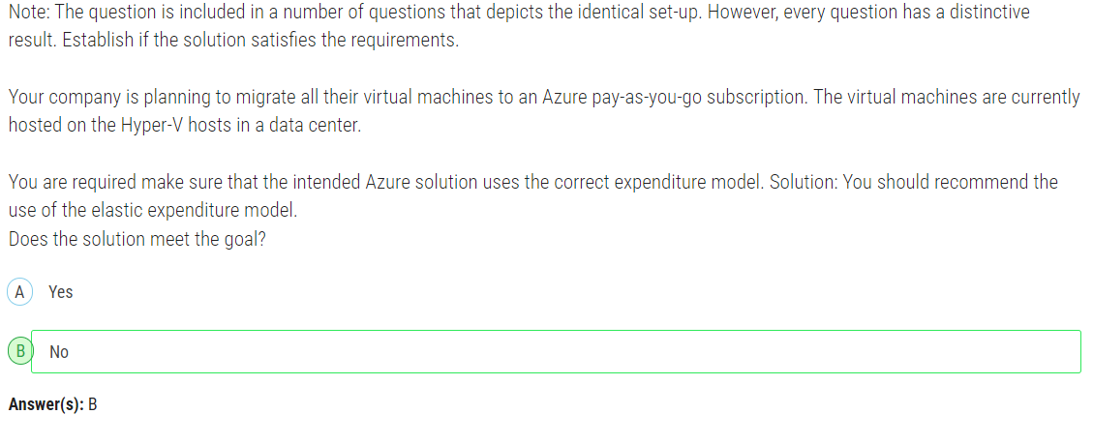

Because it should be Operational Expenditure model.

## 11.

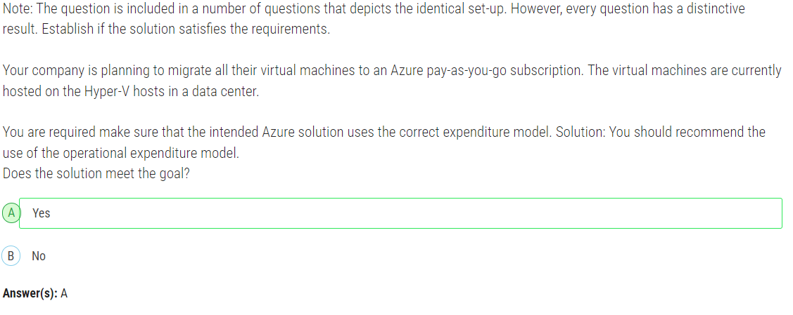

## 12.

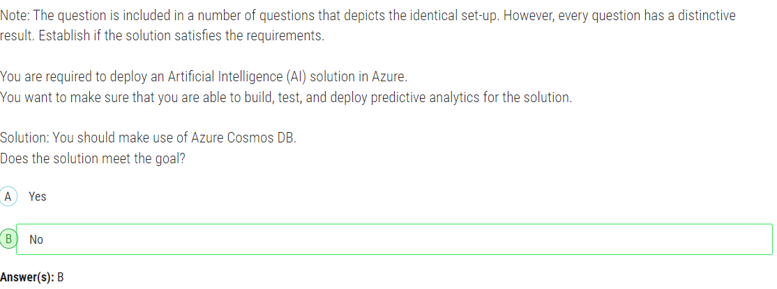

Because CosmosDB is database service. The correct answer

## 13.

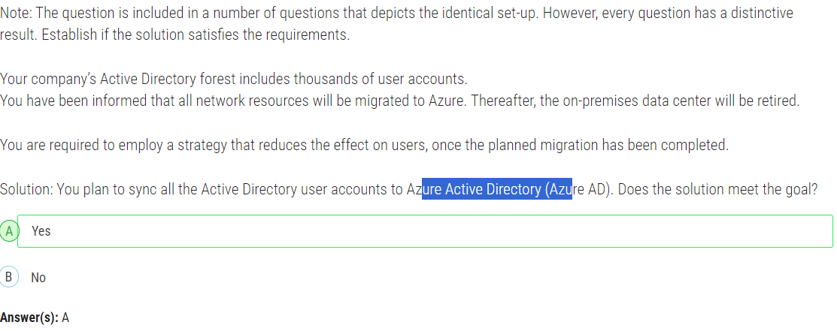

## 14.

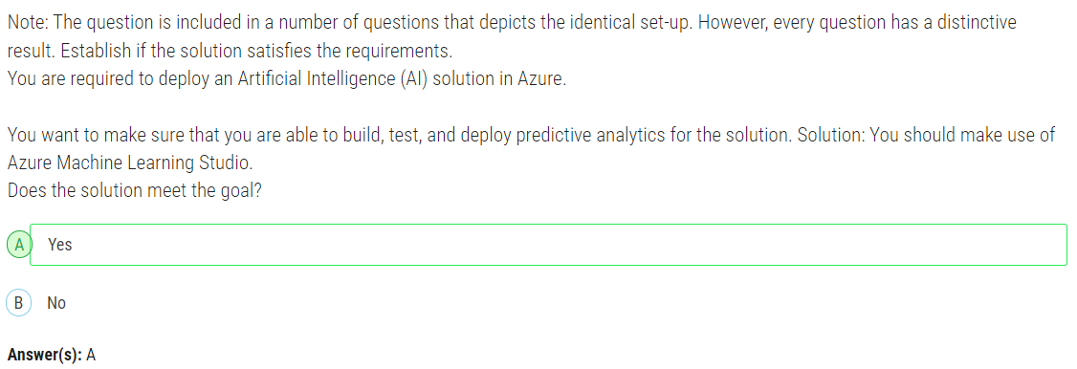

Azure Machine Learning Studio is old version of Azure Machin Learning Service. The studio does not have pipeline and has other limitations. Migrating from old service to new service is not possible.

## 15.

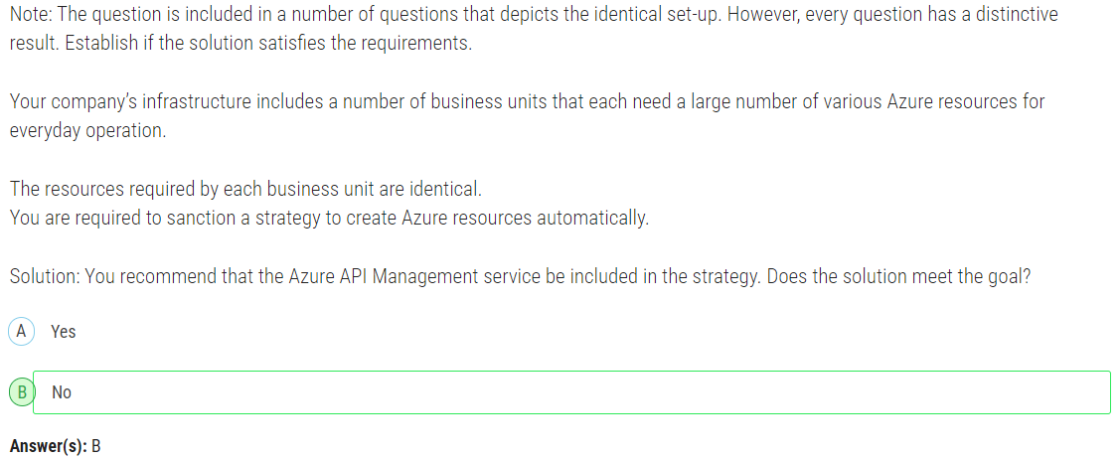

Azure API Management is a service used for creating and managing the APIs. To automate the creation of Azure resources we can use ARM templates or Azure Blueprints.

## 16.

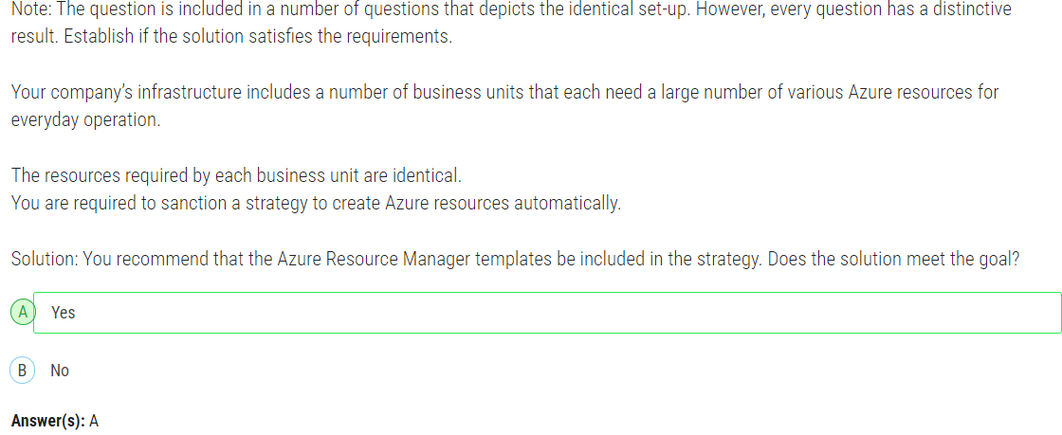

## 17.

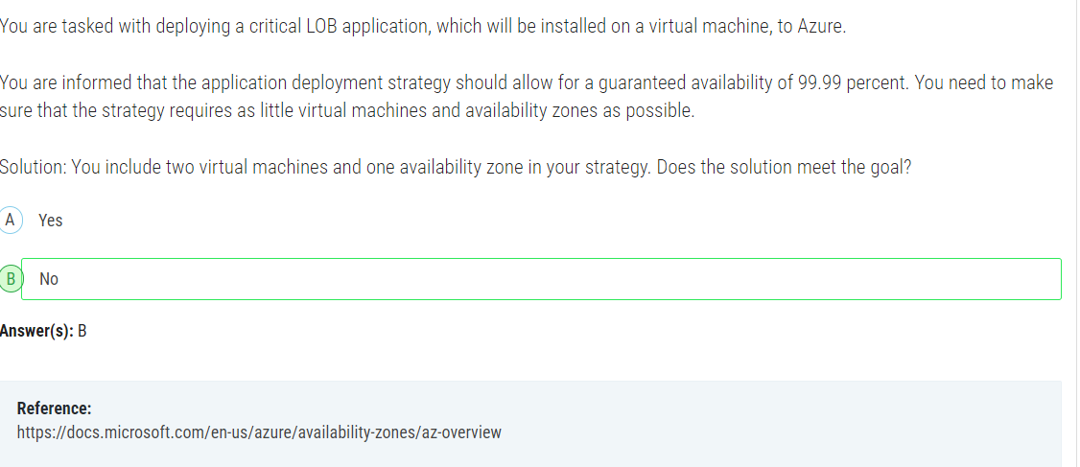

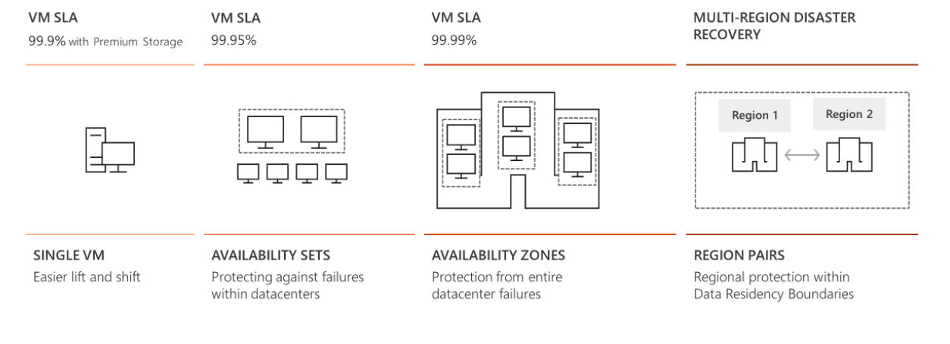

For all Virtual Machines that have two or more instances deployed across two or more Availability Zones in the same Azure region, we guarantee you will have Virtual Machine Connectivity to at least one instance at least **99.99%** of the time.

For all Virtual Machines that have two or more instances deployed in the same Availability Set or in the same Dedicated Host Group, we guarantee you will have Virtual Machine Connectivity to at least one instance at least **99.95%** of the time.

For any Single Instance Virtual Machine using Premium SSD or Ultra Disk for all Operating System Disks and Data Disks, we guarantee you will have Virtual Machine Connectivity of at least **99.9%.**

For any Single Instance Virtual Machine using Standard SSD Managed Disks for Operating System Disk and Data Disks, we guarantee you will have Virtual Machine Connectivity of at least **99.5%.** For any Single Instance Virtual Machine using Standard HDD Managed Disks for Operating System Disks and Data Disks, we guarantee you will have Virtual Machine Connectivity of at least **95%.**

## 18.

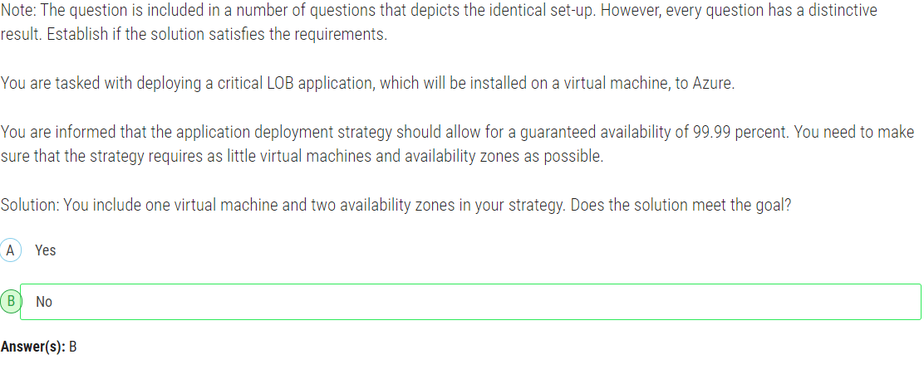

As mentioned in previous question, we need two or more VMs or instances deployed across two or more Availability Zones.

## 19.

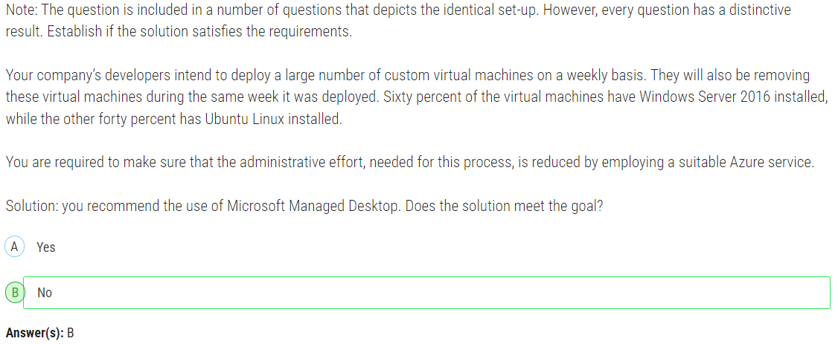

No, the solution does not meet the goal.

Microsoft Managed Desktop is a service that provides IT management of Windows 10/11 devices, focusing on delivering modern management and security features for end-user devices. It is not designed to manage the deployment, scaling, and deletion of virtual machines, particularly in an environment that involves frequent creation and deletion of VMs running different operating systems like Windows Server and Ubuntu Linux.

For your scenario, where you need to deploy and remove a large number of custom virtual machines on a weekly basis with reduced administrative effort, the appropriate Azure service would be **Azure Virtual Machine Scale Sets (VMSS)** or **Azure DevTest Labs**

## 20.

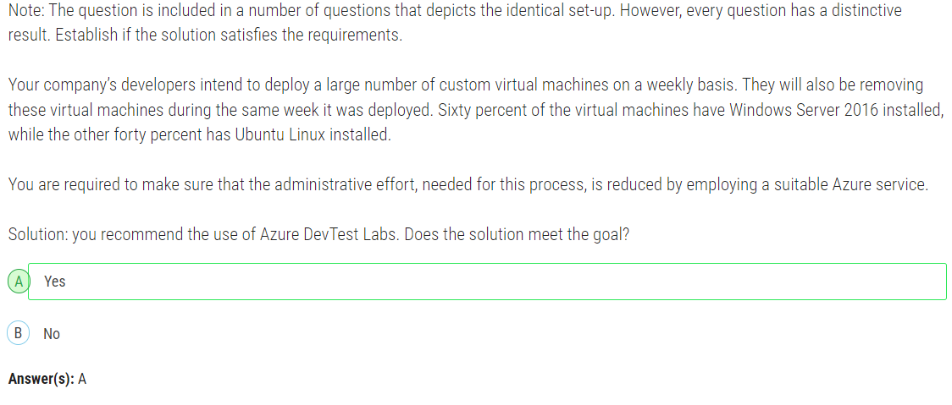

## 21.

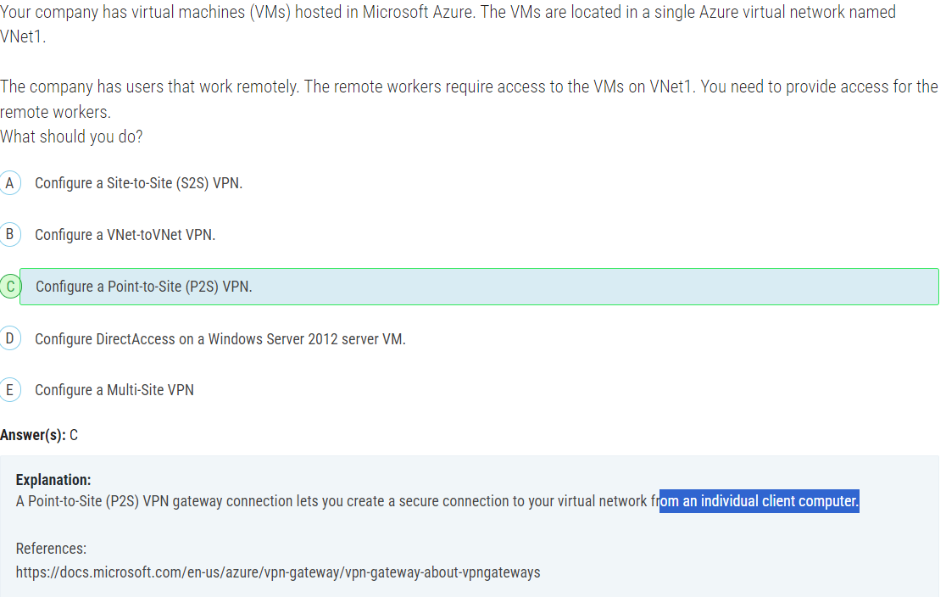

## 22.

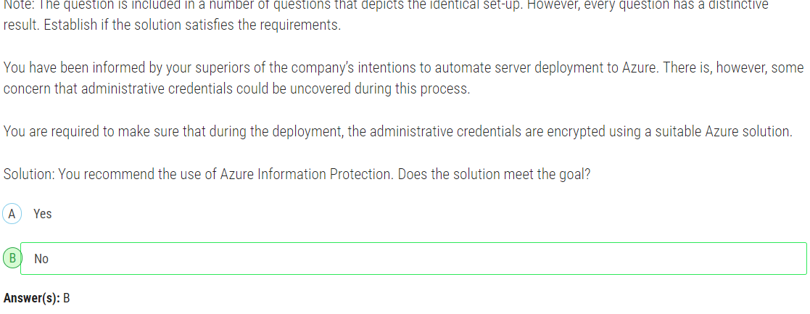

Azure Information Protection is primarily designed for classifying, labeling, and protecting documents and emails by applying labels and encryption.

For encrypting administrative credentials during server deployment to Azure, a more suitable solution would be to use **Azure Key Vault**. Azure Key Vault is a cloud service that safeguards cryptographic keys and secrets used by cloud applications and services. It provides a secure and centralized way to store and manage sensitive information such as passwords, connection strings, and other secrets.

## 23.

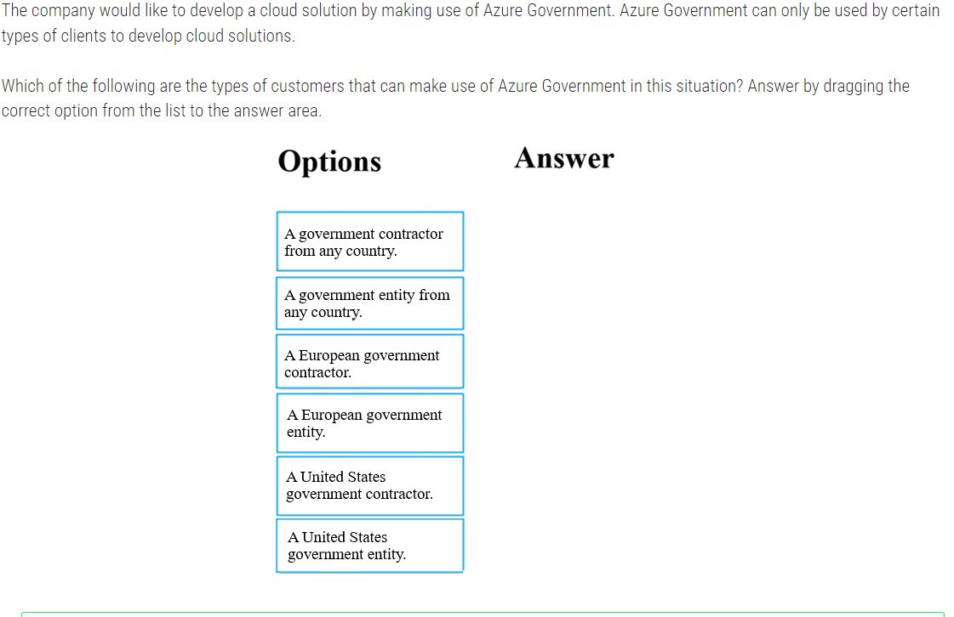

Answer:

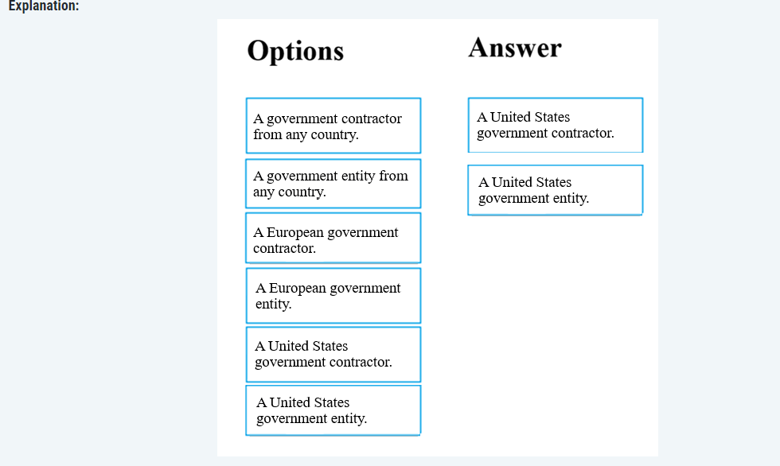

Azure Government is a cloud environment specifically built to meet compliance and security requirements for the United States government. This mission-critical cloud delivers breakthrough innovation to US government customers and their partners. Azure Government applies to government at any level — from state and local governments to federal agencies including Department of Defense agencies.

## 24.

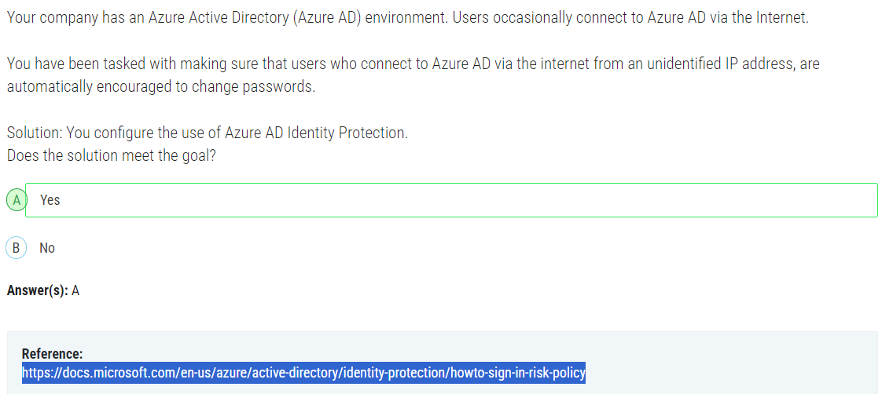

Azure AD Identity Protection provides the capability to detect risky sign-in behavior, such as sign-ins from unfamiliar locations or IP addresses, and take actions such as requiring users to change their passwords.

## 25.

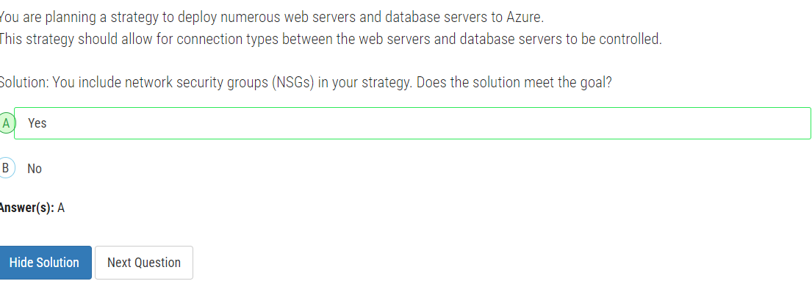

Network security groups allow you to filter network traffic to and from Azure resources in a virtual network. By associating NSGs with the subnets containing your web servers and database servers, you can define inbound and outbound security rules to permit or deny traffic based on various criteria such as source IP address, destination IP address, port, and protocol.

With NSGs, you can effectively control the communication flow between the web servers and database servers, ensuring that only the necessary connections are allowed while restricting access to unauthorized traffic.

## 26.

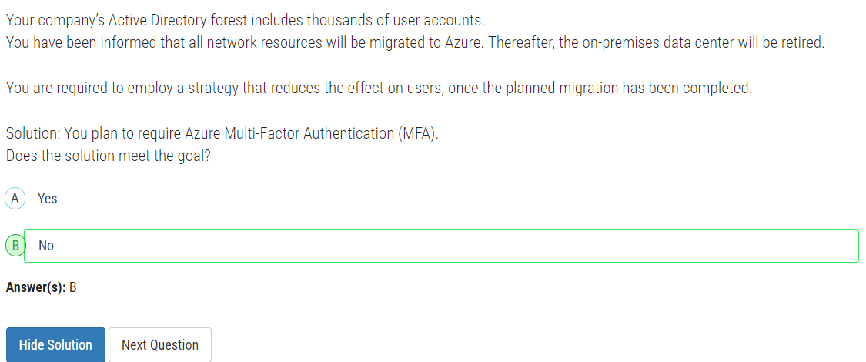

Requiring Azure Multi-Factor Authentication (MFA) as part of the migration strategy would not directly address the goal of reducing the impact on users once the migration is completed. While Azure MFA enhances security by requiring additional authentication factors, its implementation alone does not necessarily mitigate the effects on users during or after the migration process.

## 27.

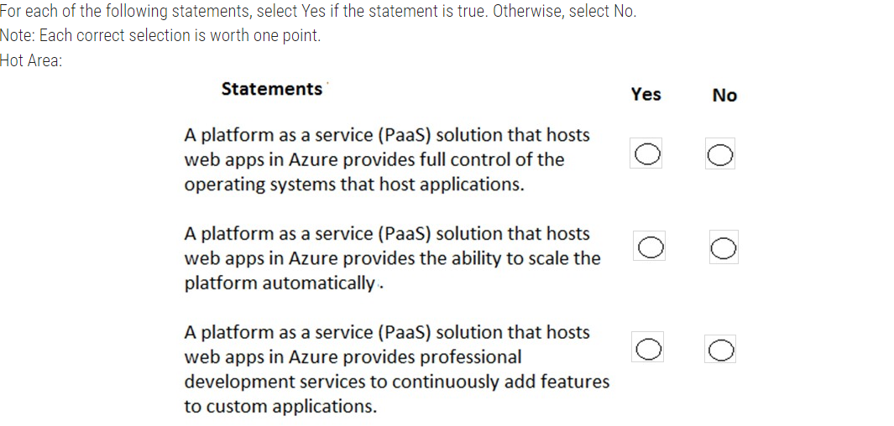

Answer:

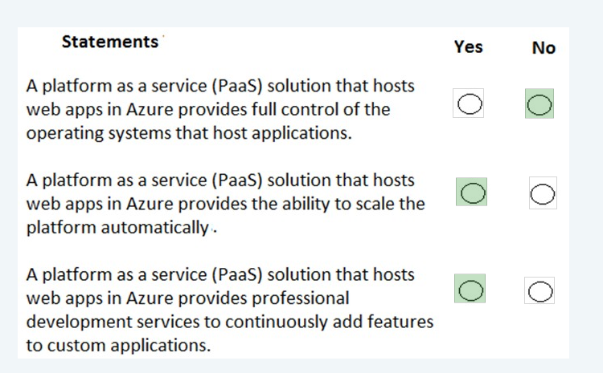

Box 1: No

A PaaS solution does not provide access to the operating system. The Azure Web Apps service provides an environment for you to host your web applications. Behind the scenes, the web apps are hosted on virtual machines running IIS. However, you have no direct access to the virtual machine, the operating system or IIS.

Box 2: Yes

A PaaS solution that hosts web apps in Azure does provide the ability to scale the platform automatically. This is known as autoscaling. Behind the scenes, the web apps are hosted on virtual machines running IIS.

Autoscaling means adding more load balanced virtual machines to host the web apps.

Box 3: Yes

PaaS provides a framework that developers can build upon to develop or customize cloud-based applications.

PaaS development tools can cut the time it takes to code new apps with pre-coded application components built into the platform, such as workflow, directory services, security features, search and so on.

## 28.

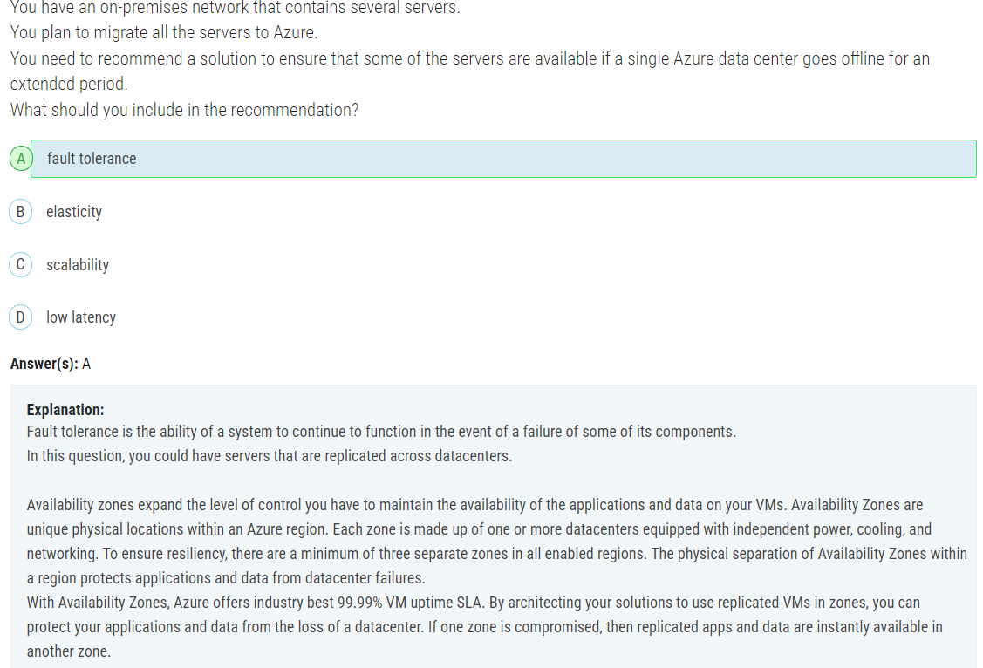

## 29.

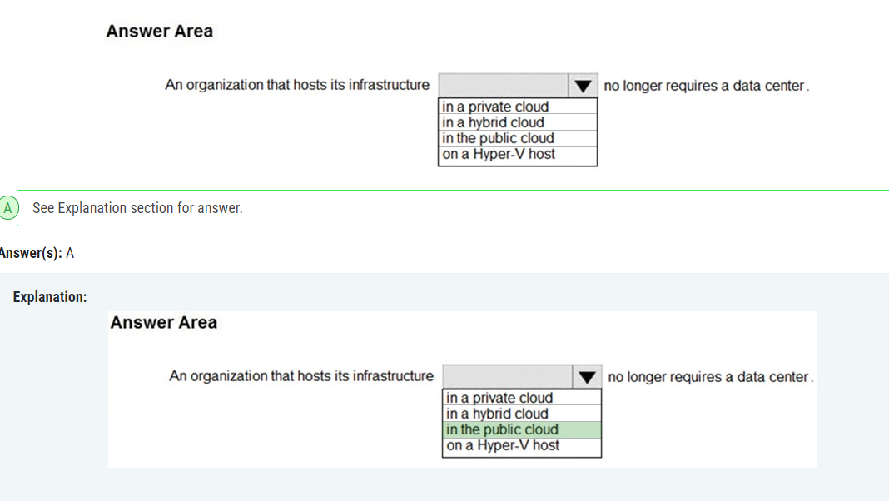

## 30.

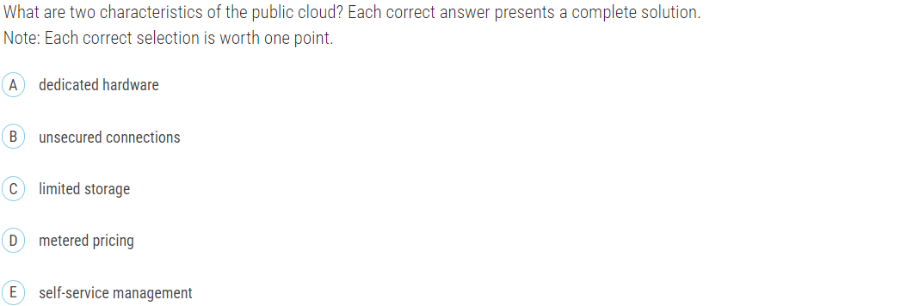



## 31.

After you answer a question in this section, you will NOT be able to return to it. As a result, these questions will not appear in the review screen.  
Your company plans to migrate all its data and resources to Azure.  
  
The company’s migration plan states that only platform as a service (PaaS) solutions must be used in Azure. You need to deploy an Azure environment that supports the planned migration.  
Solution: You create an Azure App Service and Azure SQL databases. Does this meet the goal?

1. Yes
2. No

**Answer(s):** A

**Explanation:**

Azure App Service and Azure SQL databases are examples of Azure PaaS solutions. Therefore, this solution does meet the goal.

## 32.

After you answer a question in this section, you will NOT be able to return to it. As a result, these questions will not appear in the review screen.  
Your company plans to migrate all its data and resources to Azure.  
  
The company’s migration plan states that only platform as a service (PaaS) solutions must be used in Azure. You need to deploy an Azure environment that supports the planned migration.  
Solution: You create an Azure App Service and Azure virtual machines that have Microsoft SQL Server installed.  
  
Does this meet the goal?

1. Yes
2. No

Answer: No

## 33.

Note: This question is part of a series of questions that present the same scenario. Each question in the series contains a unique solution that might meet the stated goals. Some question sets might have more than one correct solution, while others might not have a correct solution.  
  
After you answer a question in this section, you will NOT be able to return to it. As a result, these questions will not appear in the review screen.  
Your company plans to migrate all its data and resources to Azure.  
  
The company’s migration plan states that only platform as a service (PaaS) solutions must be used in Azure. You need to deploy an Azure environment that supports the planned migration.  
Solution: You create an Azure App Service and Azure Storage accounts. Does this meet the goal?

1. Yes
2. No

**Answer(s):** B

**Explanation:**

Azure App Service is a PaaS (Platform as a Service) service. However, Azure Storage accounts are an IaaS (Infrastructure as a Service) service. Therefore, this solution does not meet the goal.

## 34.

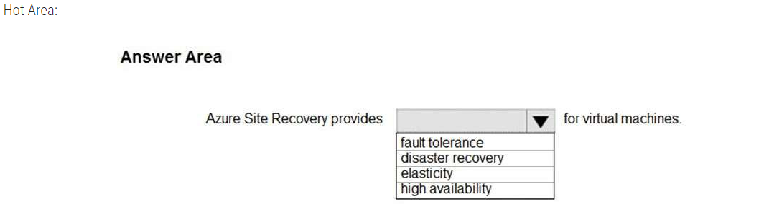

Ans: Disaster Recovery

## 35.

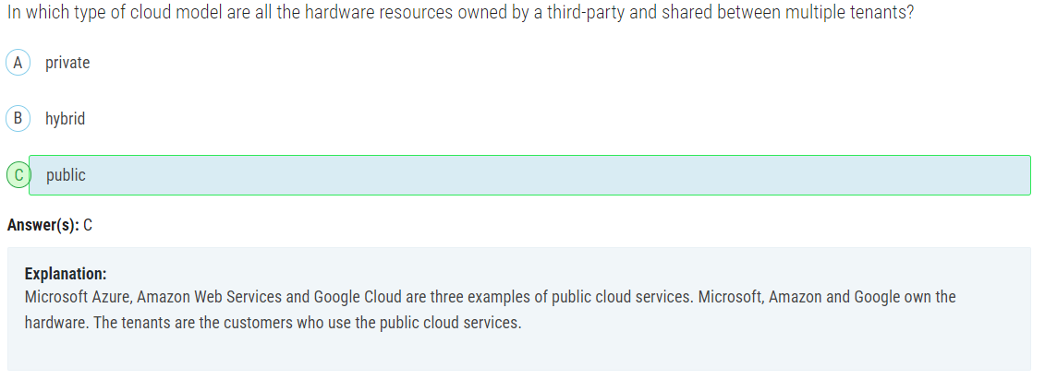

## 36.

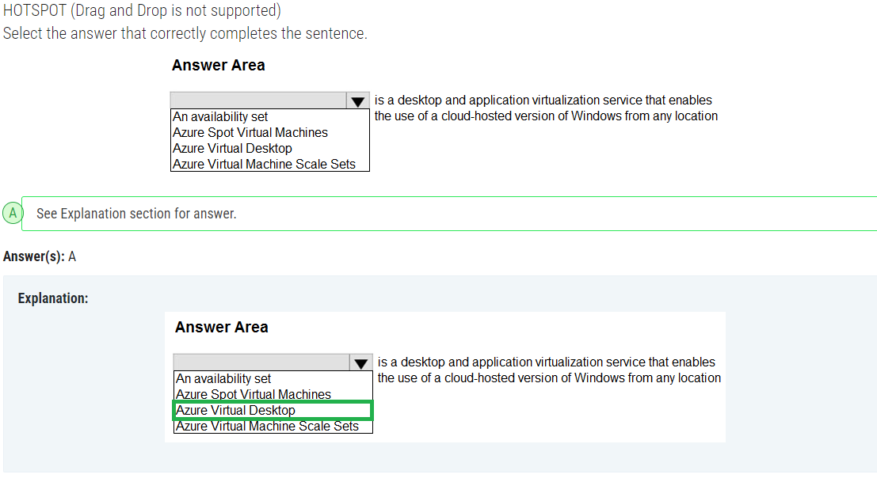

Answer: Azure Virtual Desktop

## 37.

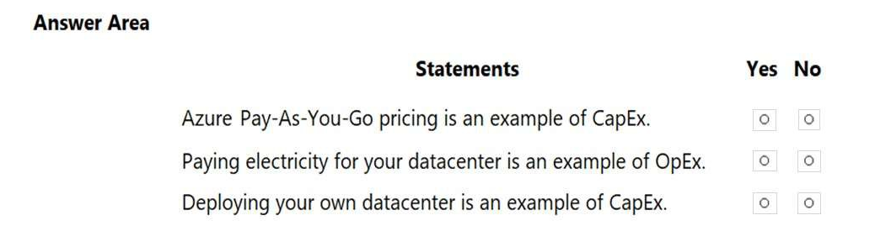

Answer: NO - YES – YES

## 38.

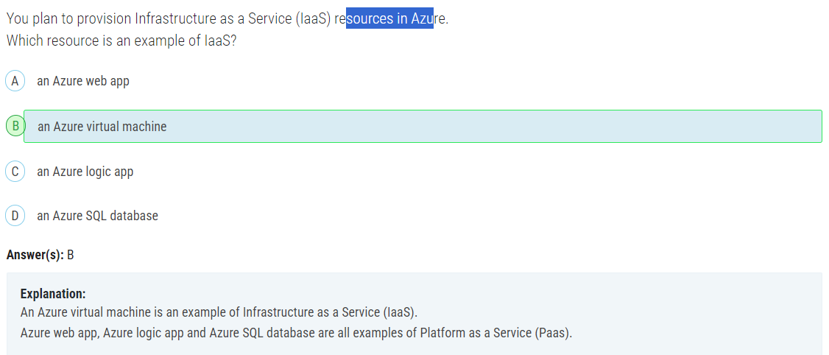

## 39.

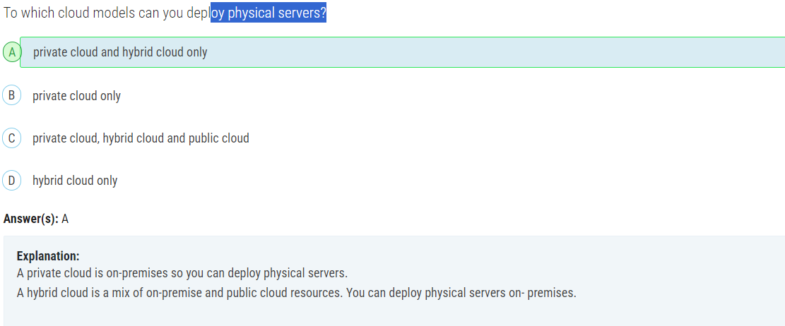

## 40.

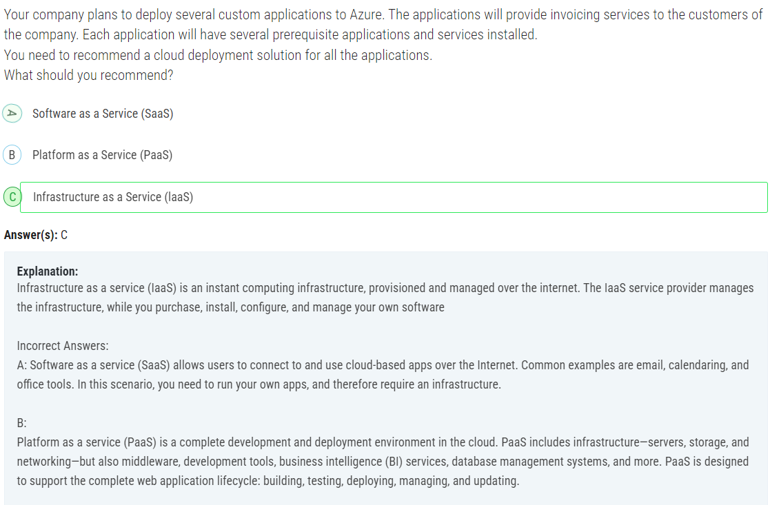

## 41.

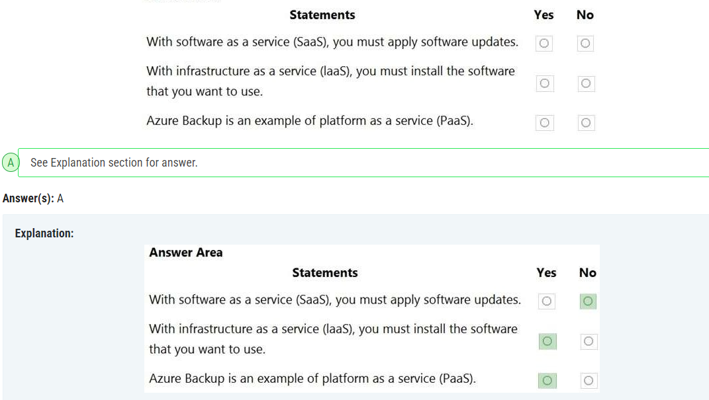

## 42.

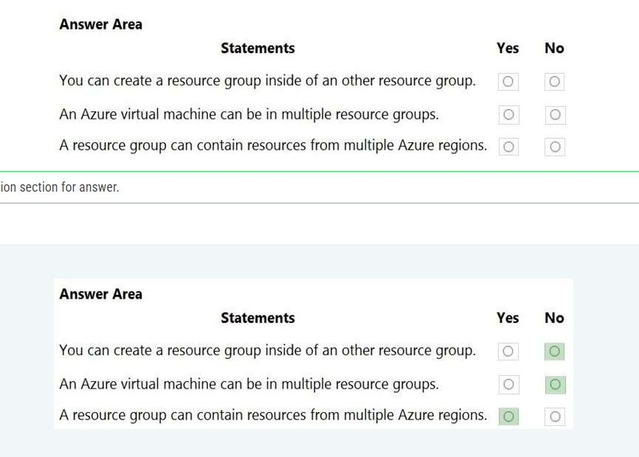

## 43.

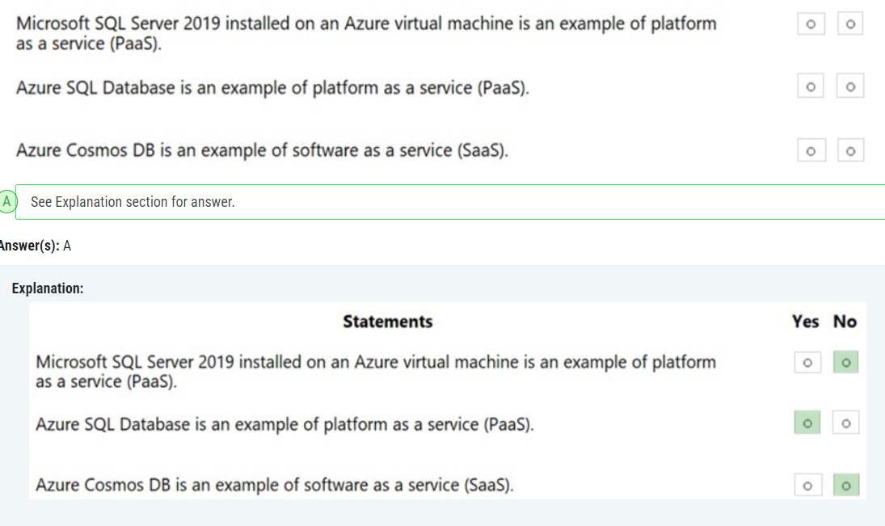

## 44.

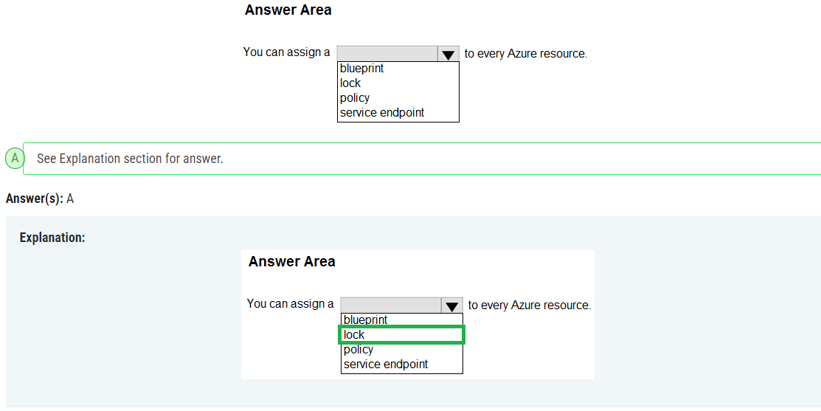

## 45.

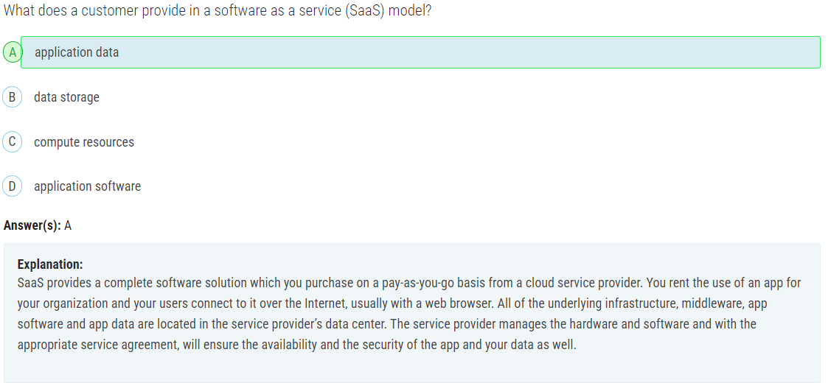

## 50.

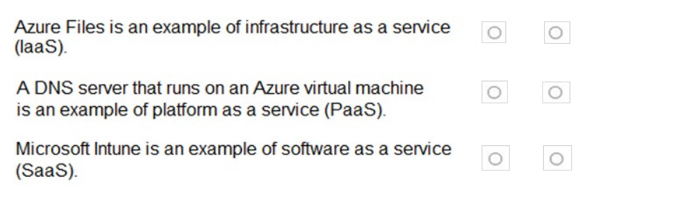

Answer:

No, because Azure Files is a PaaS.

No, because it is IaaS. IaaS (DNS on Azure VM): You manage the VM, operating system, and DNS server software. PaaS (Azure DNS): Microsoft manages the underlying infrastructure, and you only manage the DNS records and configurations.

Yes.

## 51.

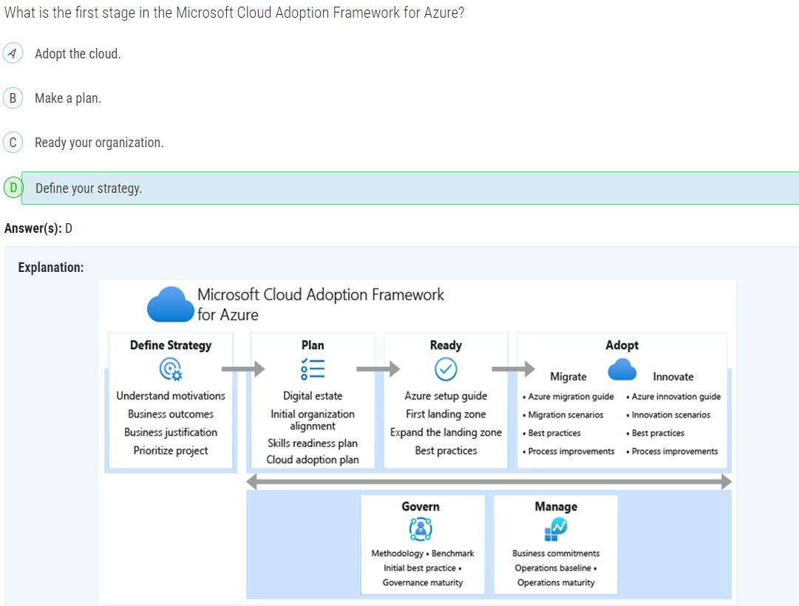

## 52.

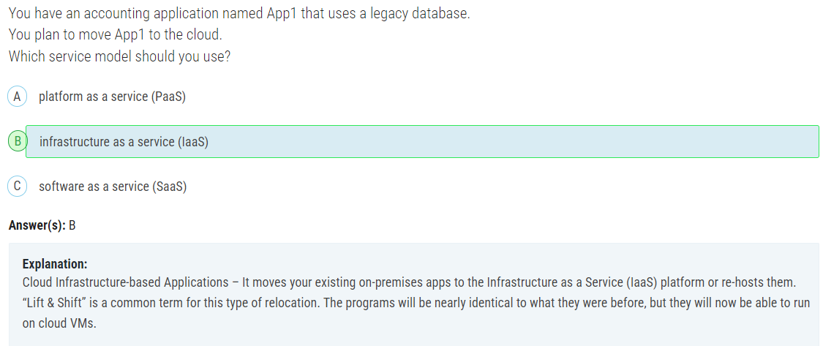

Answer: IaaS because we have to install the legacy software.

## 53.

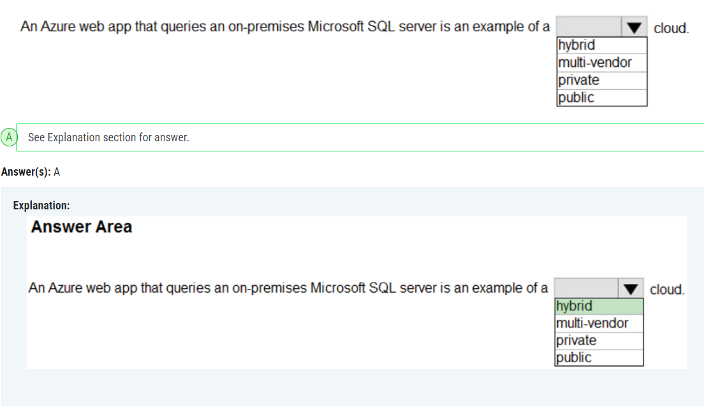

## 54.

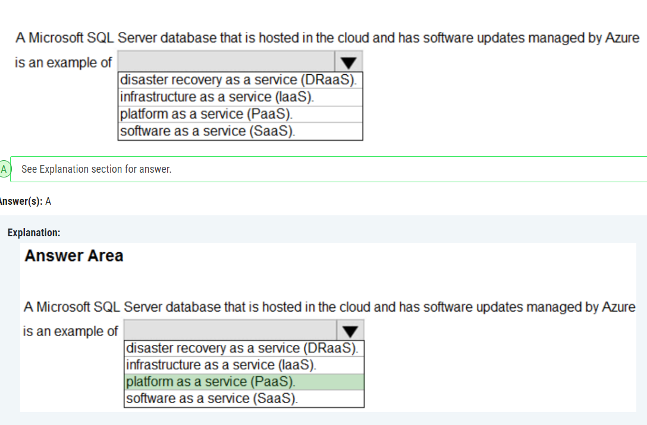

## 55.

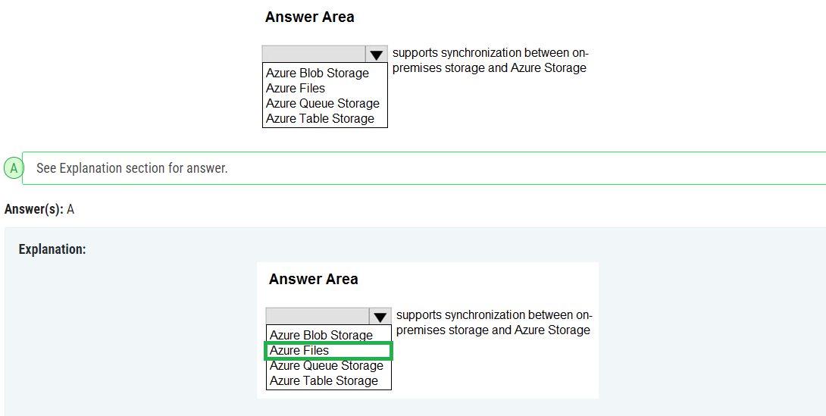

## 56.

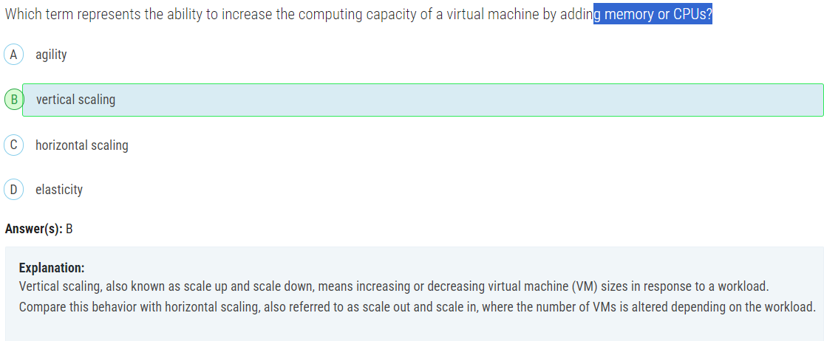

## 57.

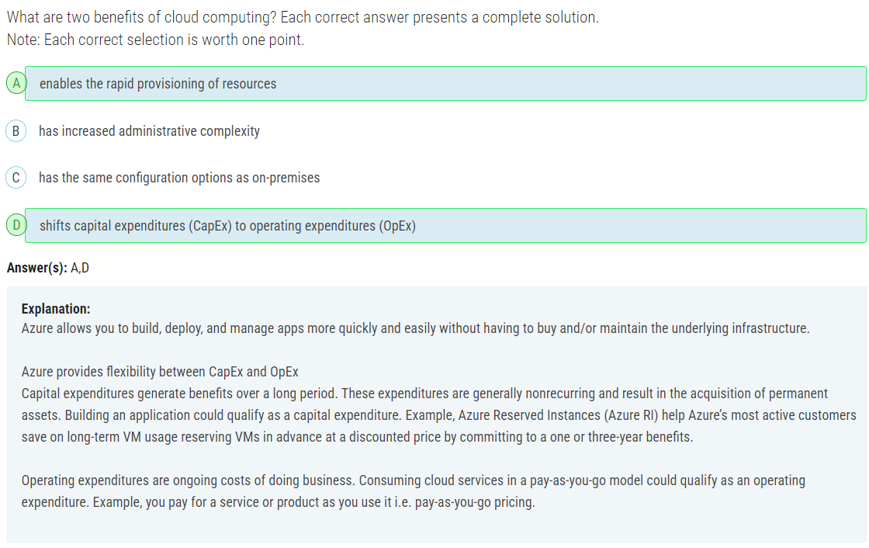

## 58.

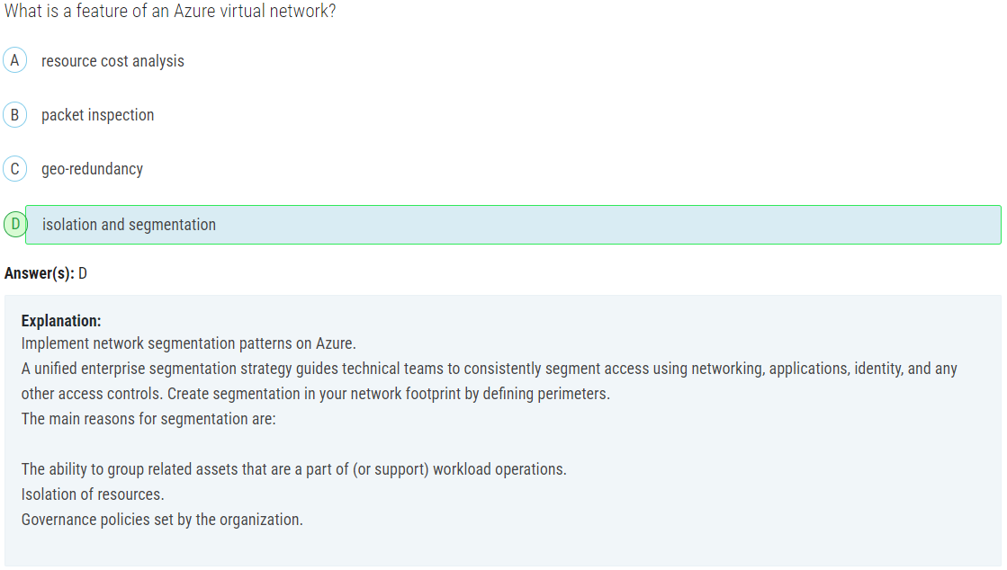

## 59.

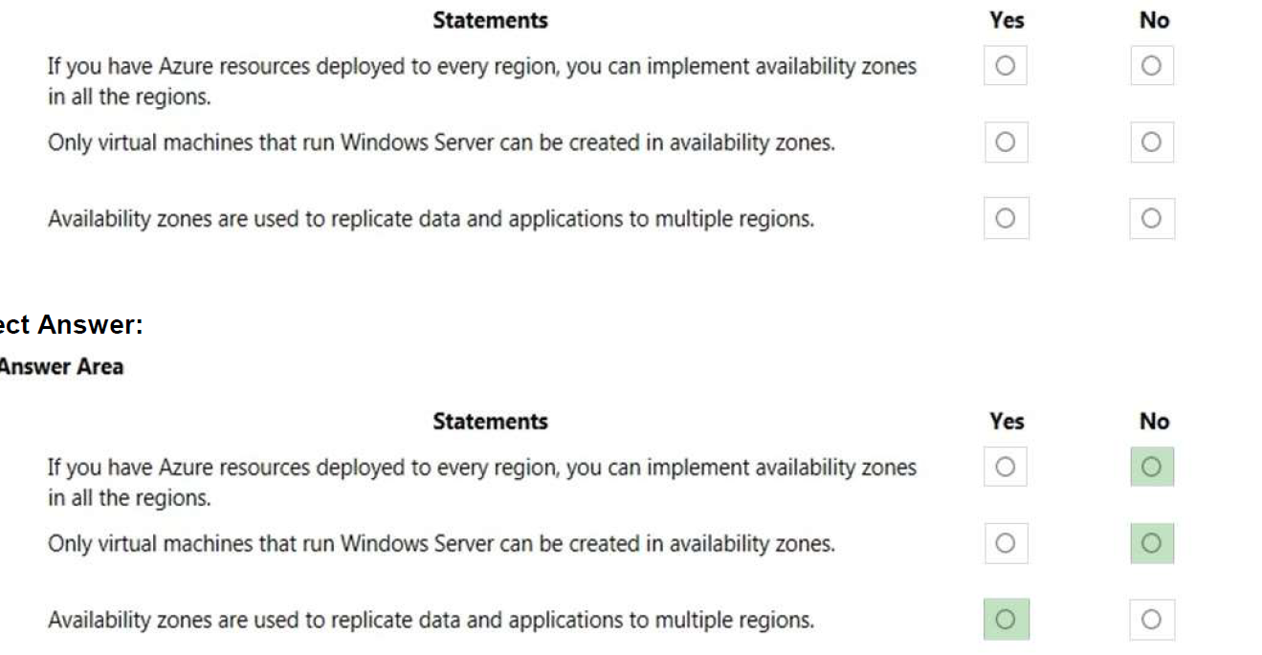

Box 1: No

Not all Azure regions support availability zones.

Box 2: No

Regions that support availability zones support Linux virtual machines.

Box 3: Yes

Availability Zones is a high-availability offering that protects your applications and data from datacenter failures.

Availability Zones are unique physical locations within an Azure region. Each zone is made up of one or more

datacenters equipped with independent power, cooling, and networking. To ensure resiliency, there’s a

minimum of three separate zones in all enabled regions. The physical separation of Availability Zones within a

region protects applications and data from datacenter failures. Zone-redundant services replicate your

applications and data across Availability Zones to protect from single-points-of-failure. With Availability Zones,

Azure offers industry best 99.99% VM uptime SLA.

## 60.

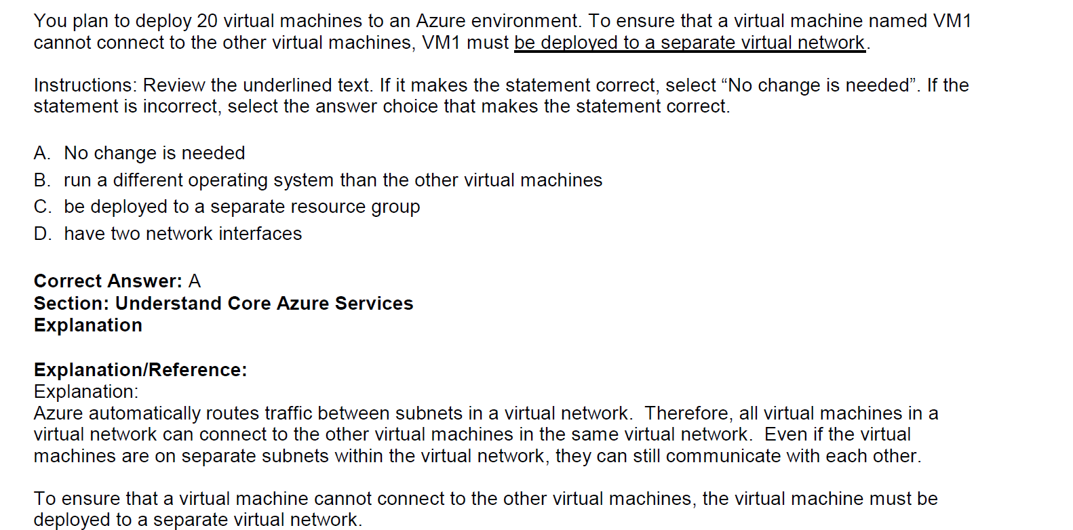

## 61.

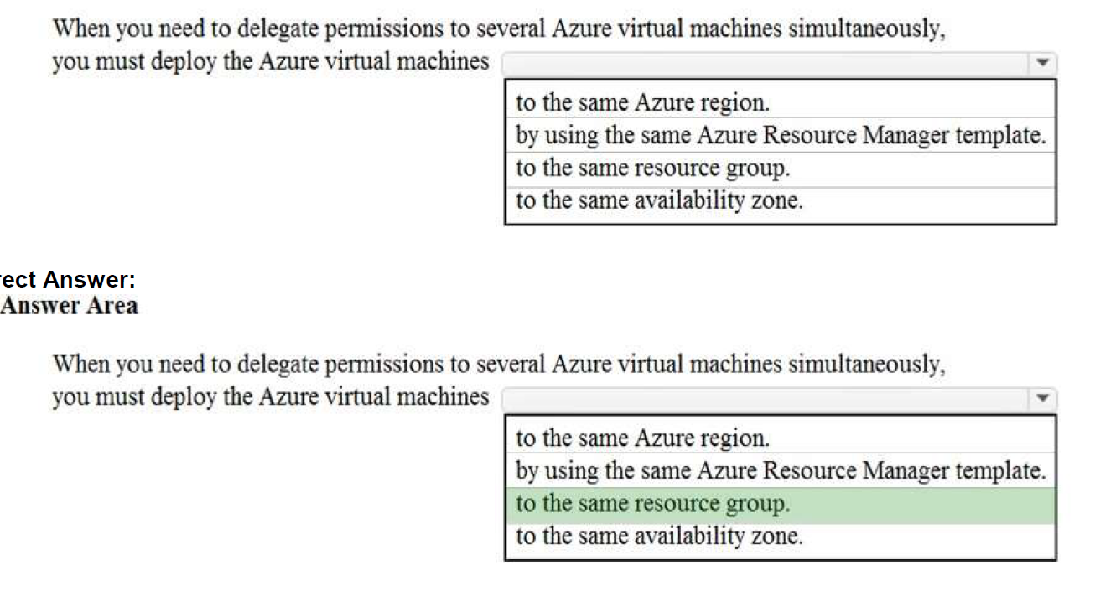

## 62.

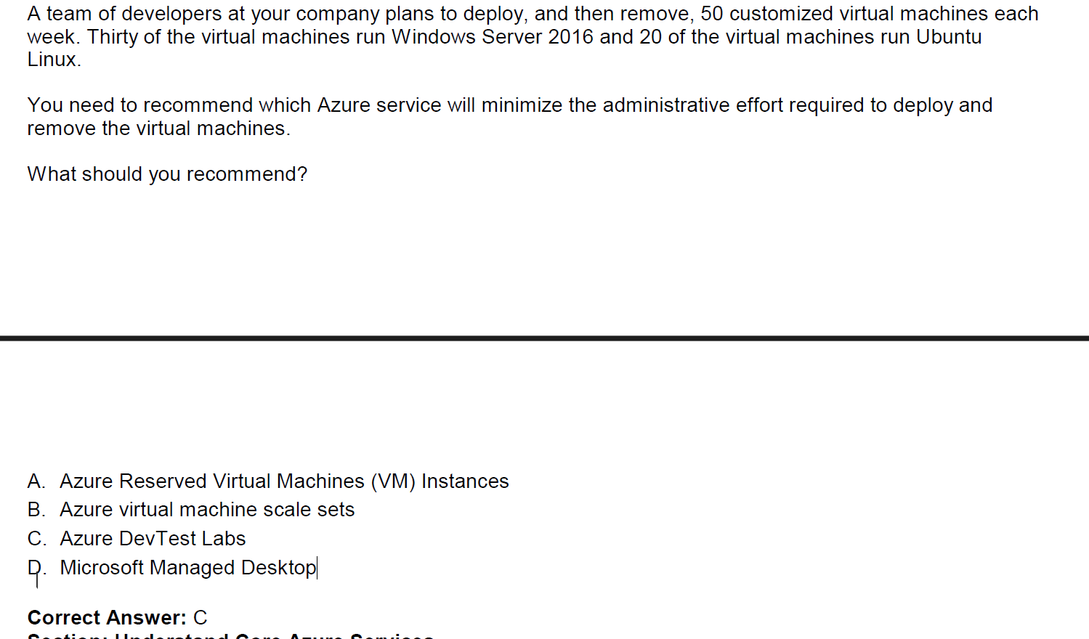

## 63.

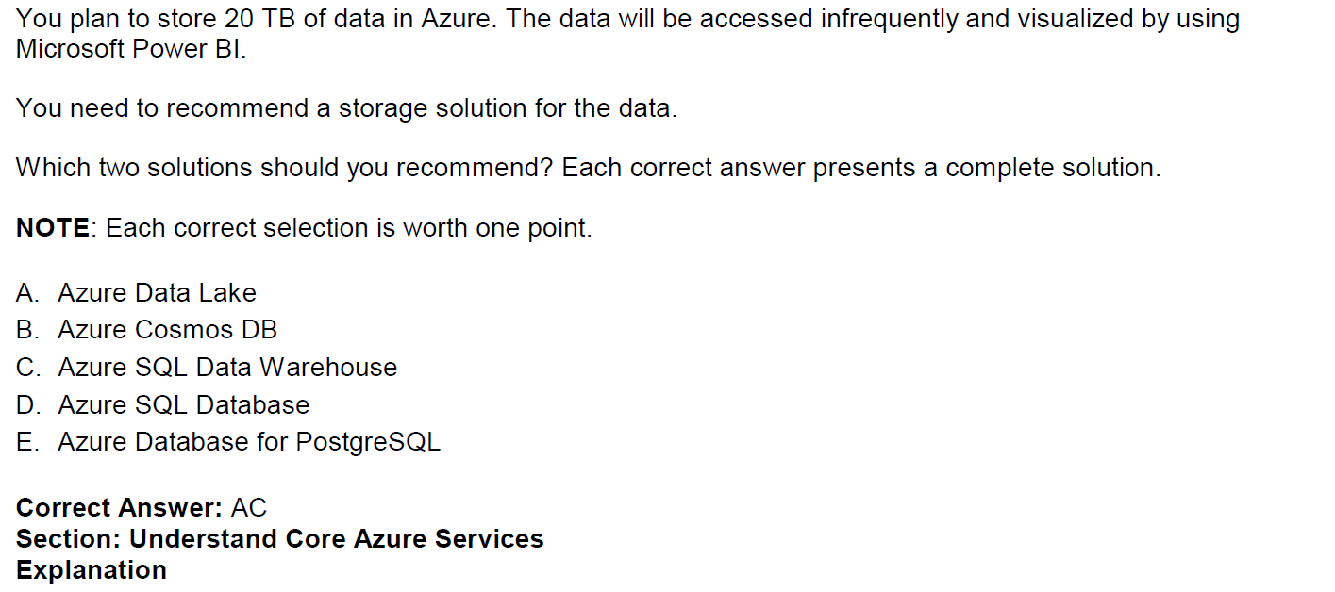

Check the Big data and analytics services.

## 64.

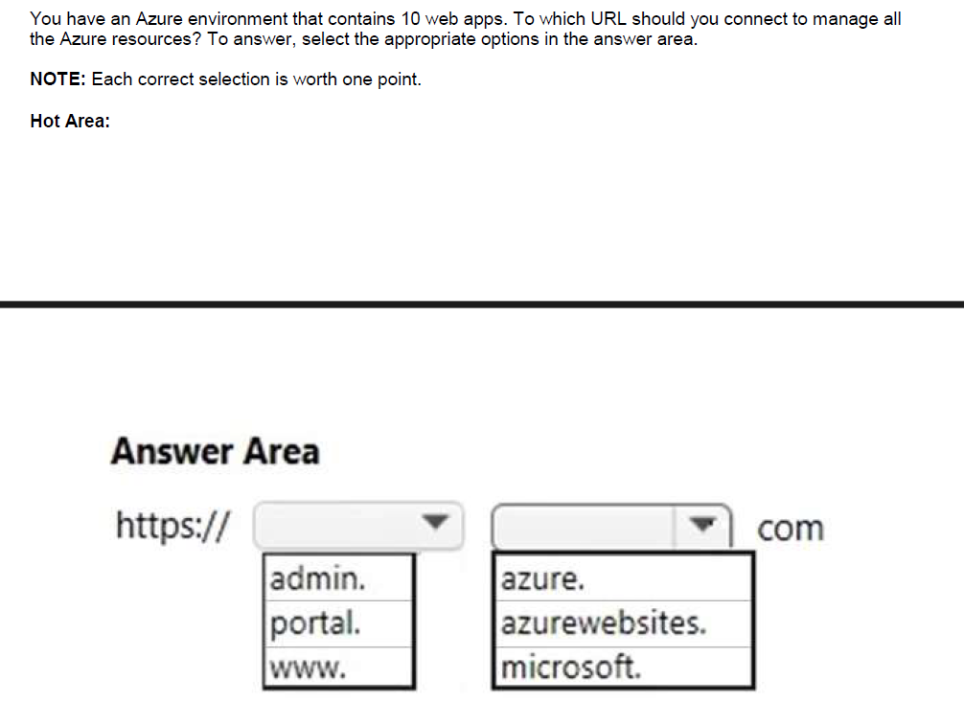

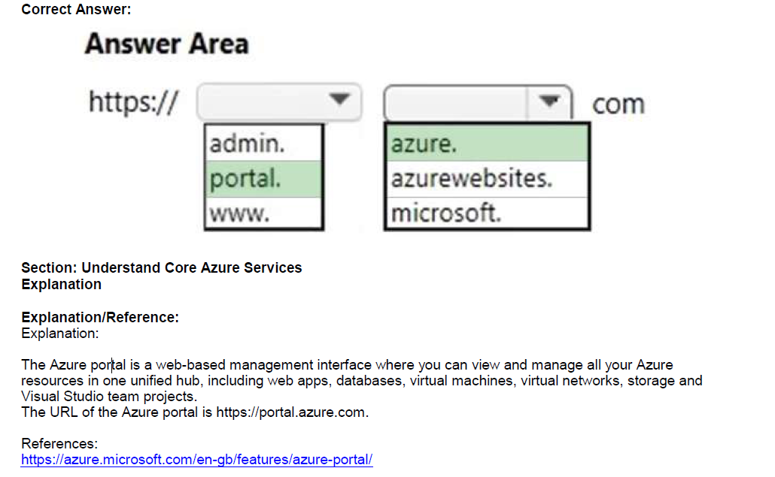

## 65.

You need to identify the type of failure for which an Azure Availability Zone can be used to protect access to

Azure services.

What should you identify?

A. a physical server failure

B. an Azure region failure

C. a storage failure

D. an Azure data center failure

Correct Answer: D

## 66. Local Network Gateway

You plan to extend your company’s network to Azure. The network contains a VPN appliance that uses an IP

address of 131.107.200.1.

You need to create an Azure resource that defines the VPN appliance in Azure.

Which Azure resource should you create? To answer, select the appropriate resource in the answer area.

Answer: Local Network Gateway

A Local Network Gateway is an object in Azure that represents your on-premise VPN device. A Virtual Network

Gateway is the VPN object at the Azure end of the VPN. A ‘connection’ is what connects the Local Network

Gateway the Virtual Network Gateway to bring up the VPN.

The local network gateway typically refers to your on-premises location. You give the site a name by which

Azure can refer to it, then specify the IP address of the on-premises VPN device to which you will create a

connection. You also specify the IP address prefixes that will be routed through the VPN gateway to the VPN

device. The address prefixes you specify are the prefixes located on your on-premises network. If your onpremises

network changes or you need to change the public IP address for the VPN device, you can easily

update the values later.

## 67.

Which Azure service should you use from the Azure portal to view service failure notifications that can affect

the availability of VM1?

A. Azure Service Fabric

B. Azure Monitor

C. Azure virtual machines

D.

Correct Answer: C

Section: Understand Core Azure Services

Explanation

Explanation/Reference:

Explanation:

In the Azure virtual machines page in the Azure portal, there is a named Maintenance Status. This column will

display service issues that could affect your virtual machine. A service failure is rare but host server

211FAFFAF232F506DC71745551D5493D

maintenance that could affect your virtual machines is more common.

Azure periodically updates its platform to improve the reliability, performance, and security of the host

infrastructure for virtual machines. The purpose of these updates ranges from patching software components

in the hosting environment to upgrading networking components or decommissioning hardware.

## 68.

An Azure administrator plans to run a PowerShell script that creates Azure resources.

You need to recommend which computer configuration to use to run the script.

Solution: Run the script from a computer that runs Chrome OS and uses Azure Cloud Shell.

Does this meet the goal?

211FAFFAF232F506DC71745551D5493D

A. Yes

B. No

Correct Answer: A

Section: Understand Core Azure Services

Explanation

Explanation/Reference:

Explanation:

A PowerShell script is a file that contains PowerShell cmdlets and code. A PowerShell script needs to be run in

PowerShell.

With the Azure Cloud Shell, you can run PowerShell cmdlets and scripts in a Web browser. You log in to the

Azure Portal and select the Azure Cloud Shell option. This will open a PowerShell session in the Web browser.

The Azure Cloud Shell has the necessary Azure PowerShell module installed.

Note: to run a PowerShell script in the Azure Cloud Shell, you need to change to the directory where the

PowerShell script is stored.

## 69.

An Azure administrator plans to run a PowerShell script that creates Azure resources.

You need to recommend which computer configuration to use to run the script.

Solution: Run the script from a computer that runs macOS and has PowerShell Core 6.0 installed.

Does this meet the goal?

A. Yes

B. No

Correct Answer: A

A PowerShell script is a file that contains PowerShell cmdlets and code. A PowerShell script needs to be run in

PowerShell.

In this question, the computer has PowerShell Core 6.0 installed. Therefore, this solution does meet the goal.

## 70.

An Azure administrator plans to run a PowerShell script that creates Azure resources.

You need to recommend which computer configuration to use to run the script.

Solution: Run the script from a computer that runs Linux and has the Azure CLI tools installed.

Does this meet the goal?

A. Yes

B. No

Correct Answer: B

Section: Understand Core Azure Services

Explanation

Explanation/Reference:

Explanation:

A PowerShell script is a file that contains PowerShell cmdlets and code. A PowerShell script needs to be run in

PowerShell.

PowerShell can now be installed on Linux. However, the question states that the computer has Azure CLI tools,

not PowerShell installed. Therefore, this solution does not meet the goal.

## 71.

You need to limit the amount of inbound traffic to all the Azure virtual networks.

What should you create?

A. one application security group (ASG)

B. 10 virtual network gateways

C. 10 Azure ExpressRoute circuits

D. one Azure firewall

Correct Answer: D

Section: Understand Core Azure Services

Explanation

Explanation/Reference:

Explanation:

You can restrict traffic to multiple virtual networks with a single Azure firewall.

Azure Firewall is a managed, cloud-based network security service that protects your Azure Virtual Network

resources. It's a fully stateful firewall as a service with built-in high availability and unrestricted cloud scalability.

You can centrally create, enforce, and log application and network connectivity policies across subscriptions

and virtual networks. Azure Firewall uses a static public IP address for your virtual network resources allowing

outside firewalls to identify traffic originating from your virtual network.

## 72.

You need to view a list of planned maintenance events that can affect the availability of an Azure subscription.

Which blade should you use from the Azure portal? To answer, select the appropriate blade in the answer

area.

Answer:

Service Health

## 73.

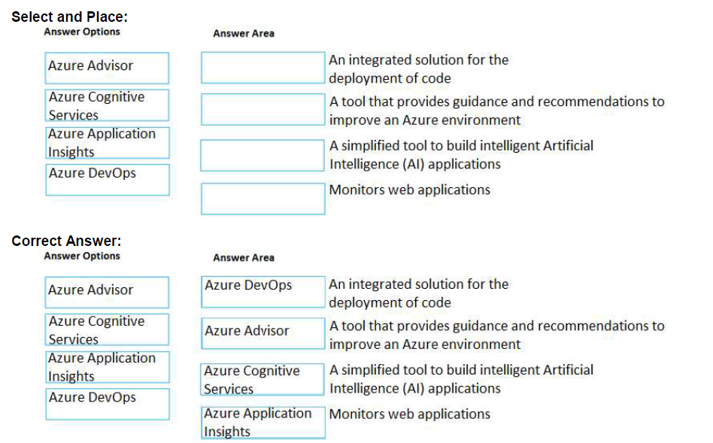

## 74.

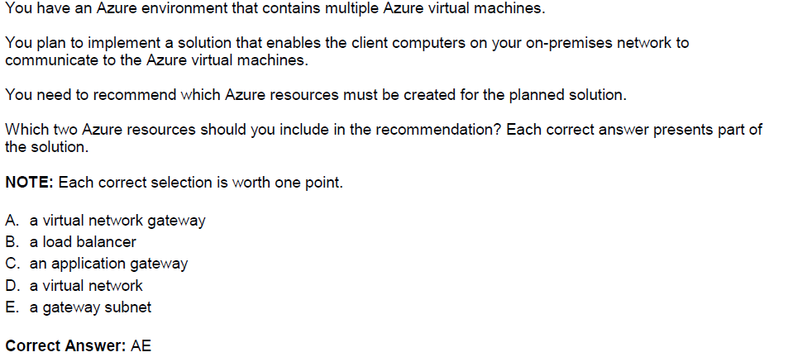

## 75.

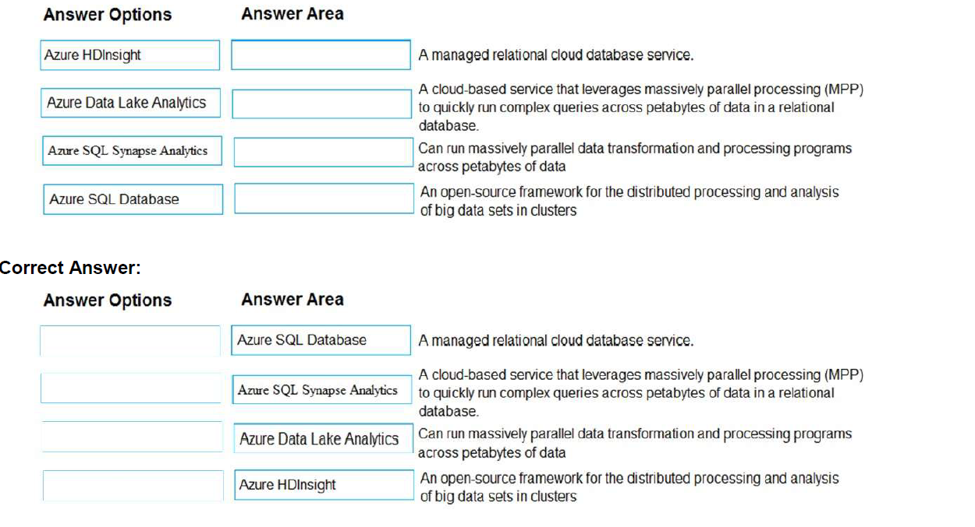

## 76.

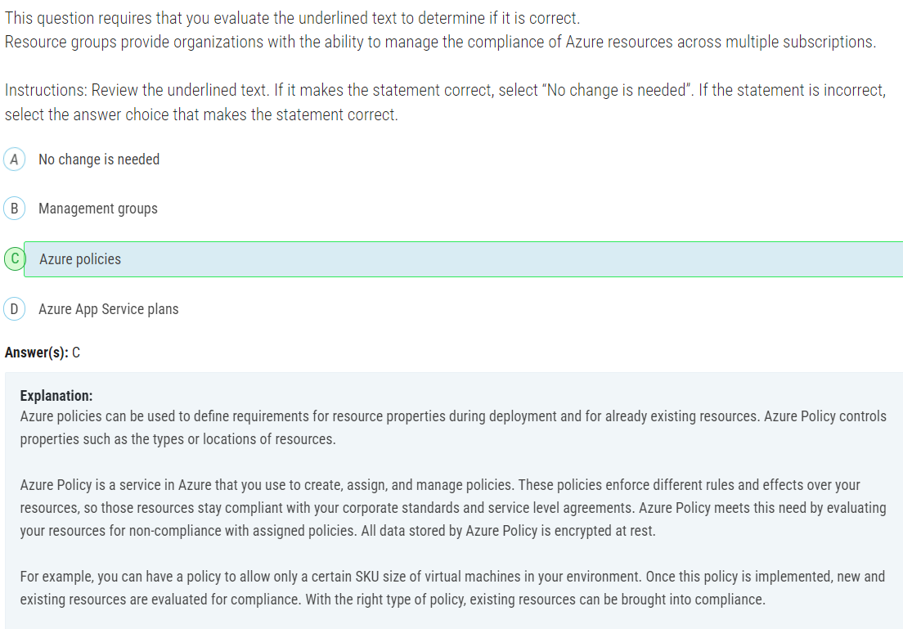

## 77.

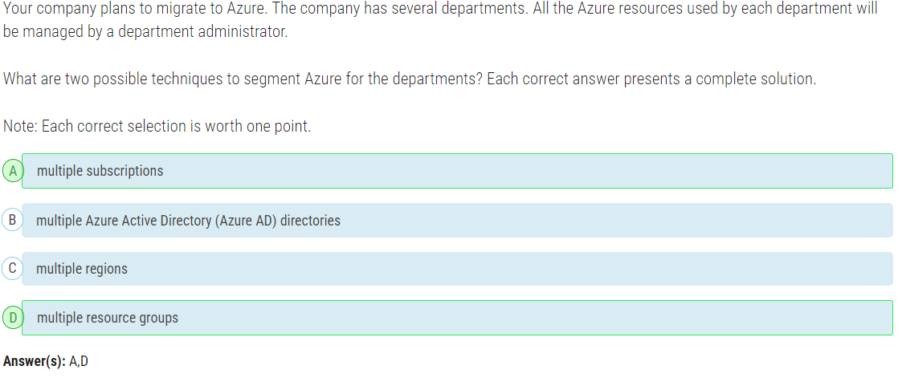

An Azure subscription is a container for Azure resources. It is also a boundary for permissions to resources and for billing. You are charged monthly for all resources in a subscription. A single Azure tenant (Azure Active Directory) can contain multiple Azure subscriptions.

A resource group is a container that holds related resources for an Azure solution. The resource group can include all the resources for the solution, or only those resources that you want to manage as a group.

## 78.

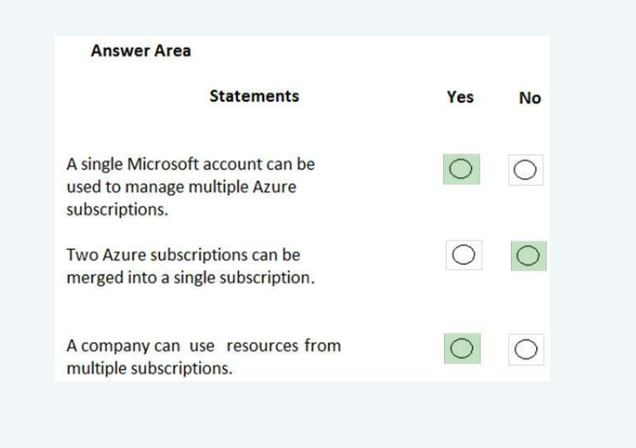

## 79.

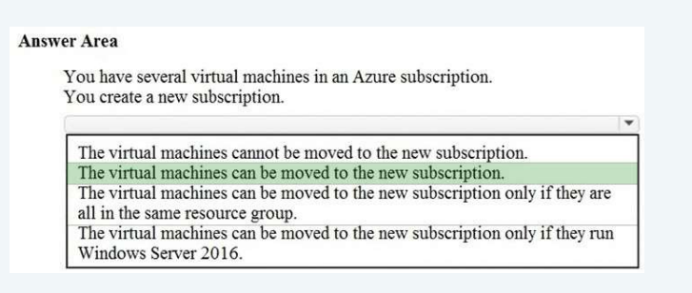

## 80.

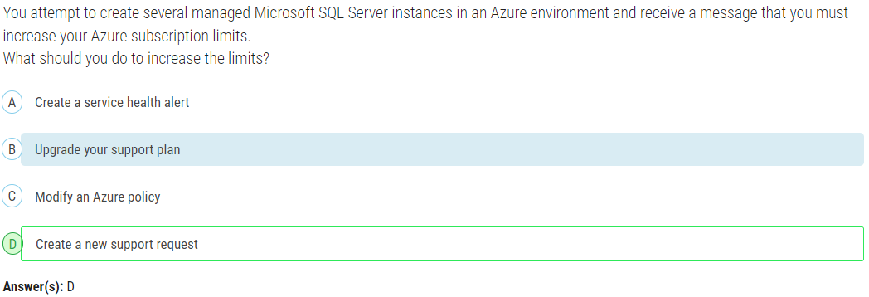

## 81.

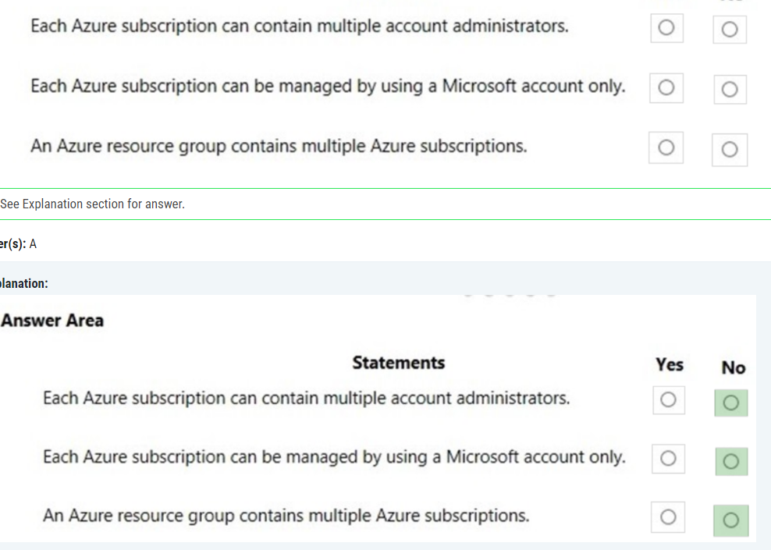

## 82.

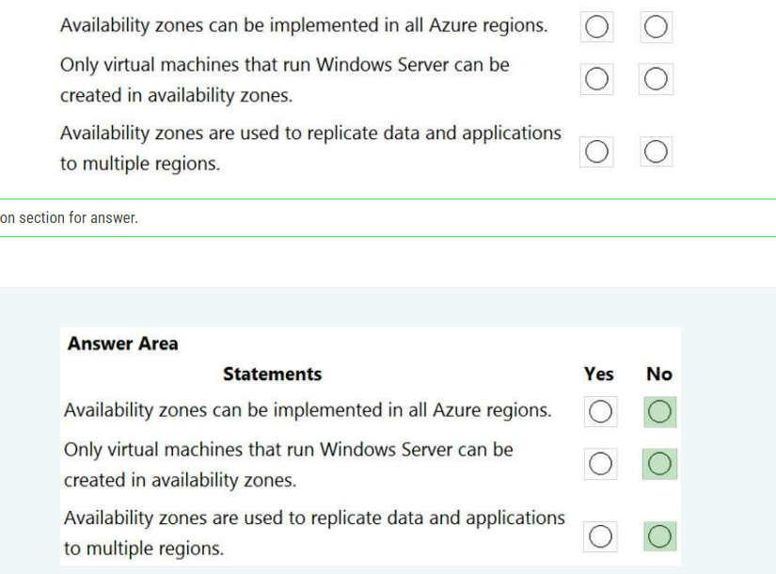

Answer:

3. Availability Zones are used to replicate data and applications across multiple locations within the same region, not across multiple regions. To replicate data and applications across multiple regions, you would use multiple Azure regions.

## 83.

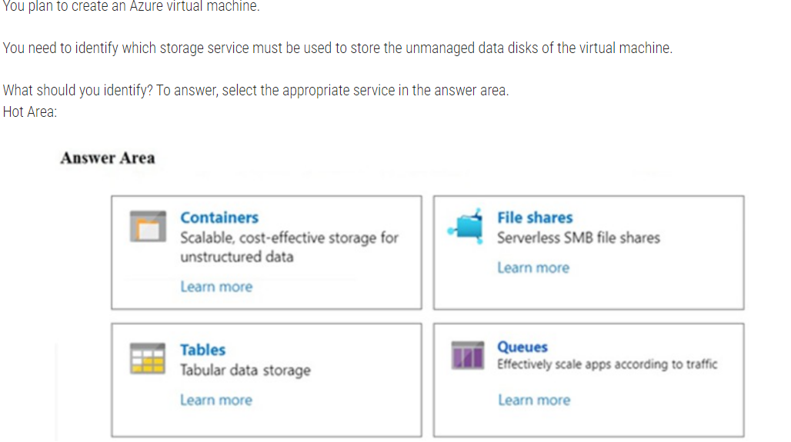

Azure containers are the backbone of the virtual disks platform for Azure IaaS. Both Azure OS and data disks are implemented as virtual disks where data is durably persisted in the Azure Storage platform and then delivered to the virtual machines for maximum performance. Azure Disks are persisted in Hyper-V VHD format and stored as a page blob in Azure Storage.

## 84.

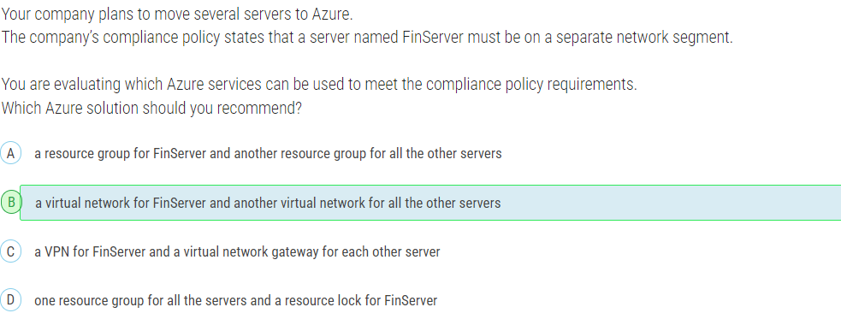

## 85.

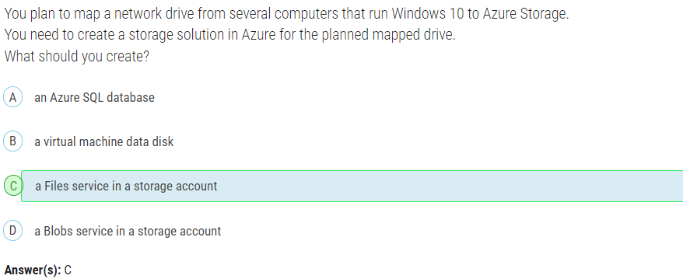

## 86.

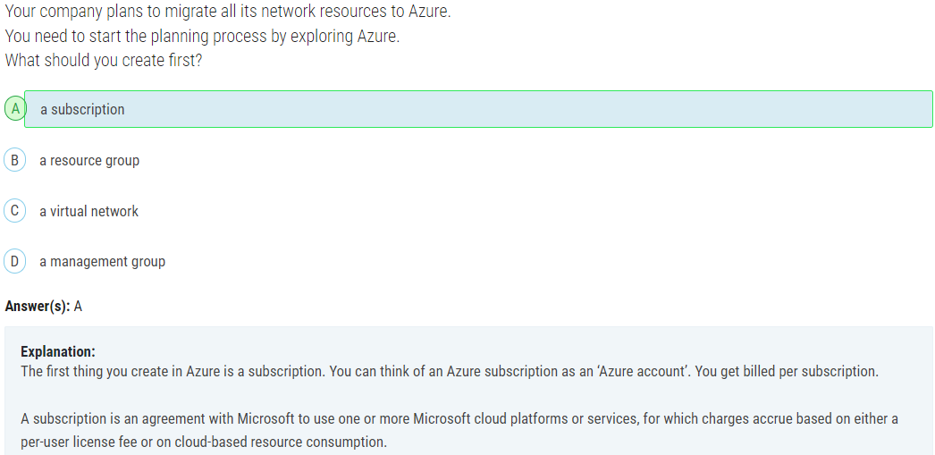

## 87.

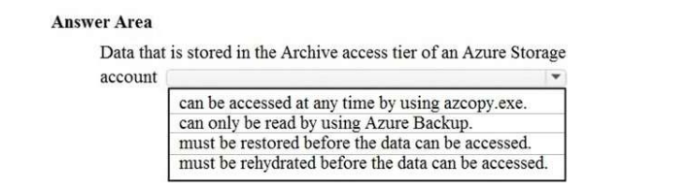

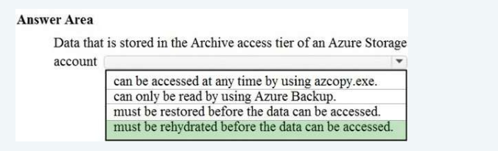

## 88.

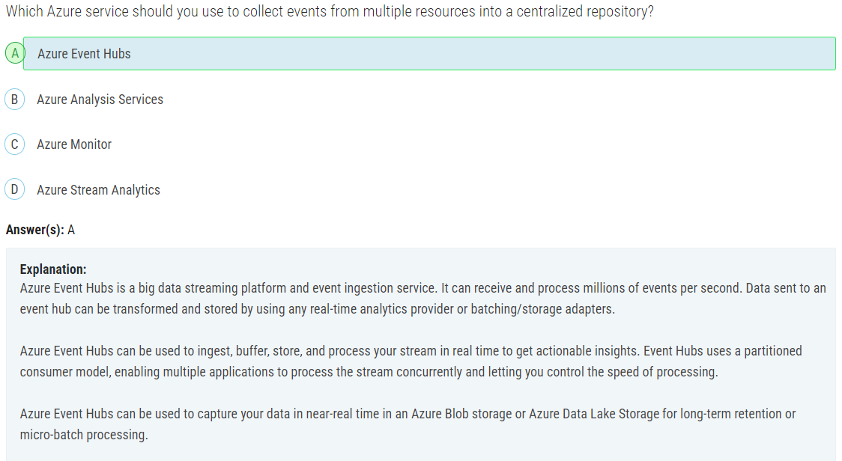

## 89.

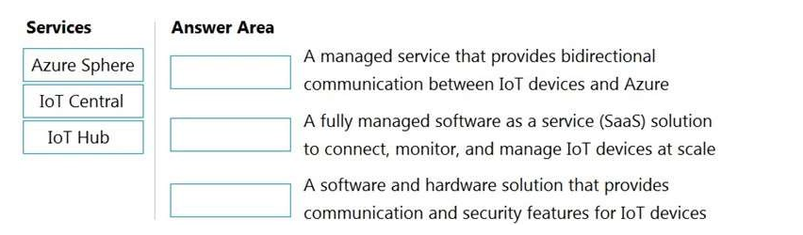

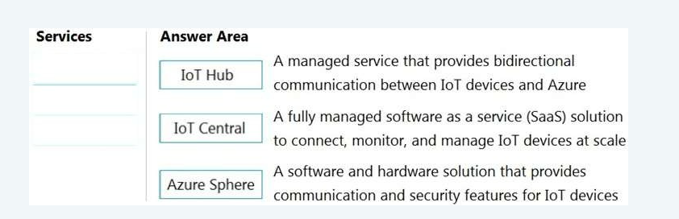

## 90.

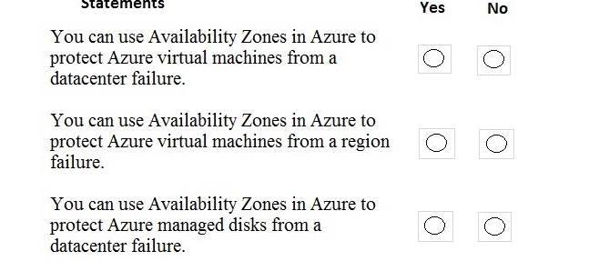

Answer: Y-N-Y

## 91.

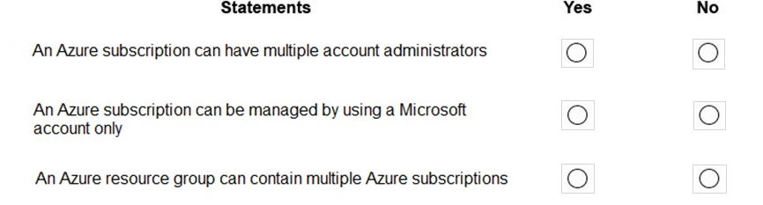

Answer: N-N-N

## 92.

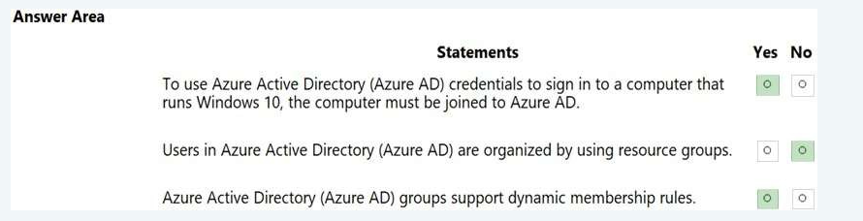

## 93. Resource Lock

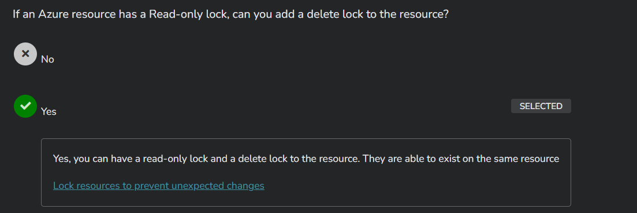

## 94. ARM

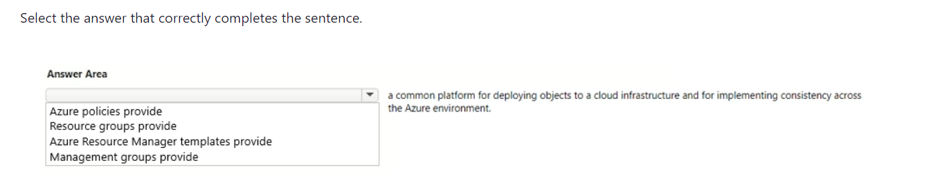

Answer: ARM templates

## 95.

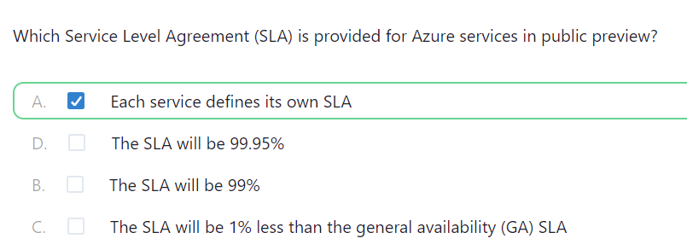

## 96.

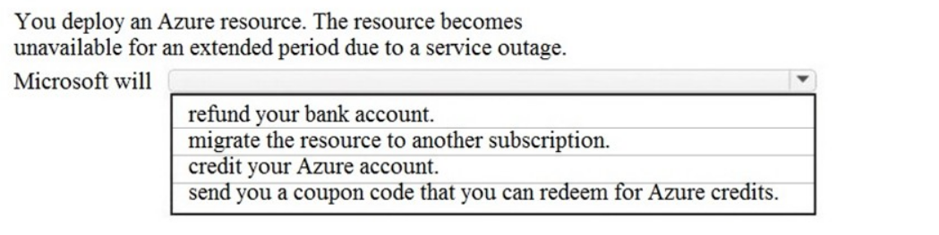

Answer: Credit your Azure account

## 97. Storage account name must be unique

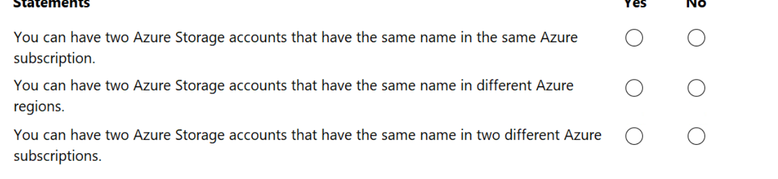

Answer:

NO-NO-NO, because the storage account name must be unique across all of Azure. This means that if you choose a name like "abc" for your storage account, no other person or entity in Azure, regardless of region or subscription, can use the name "abc" for their storage account. The uniqueness requirement ensures that each storage account can be distinctly identified within the global Azure namespace.

## 98.

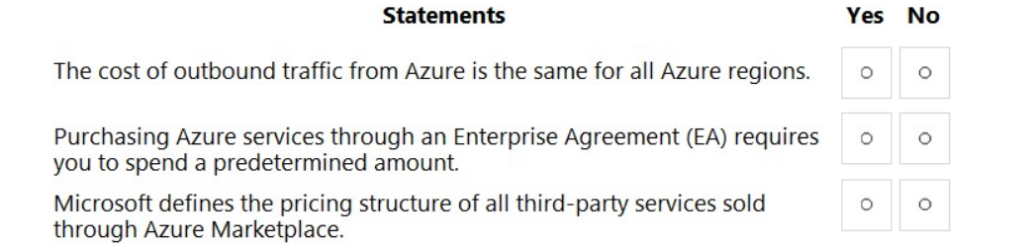

Answer:

No-Yes-No

Box 1: No -

Within most of the areas, there are clearly more expensive regions and less expensive regions. The least expensive regions, on average across these instance types are us-west-2, us-west-central, and korea-south. The most expensive regions are asia-pacific-east, japan-east, and australia-east.

Box 2: Yes -

Many organizations with Microsoft Enterprise Agreements (EA) are adding Azure to their EA to enjoy the benefits it offers, such as:

Minimizing Azure upfront costs by locking in pricing with consumption pre-commitment

Using Azure EA Portal to manage Azure Subscriptions easily and organize them under a single billing account

## 99. Azure Arc

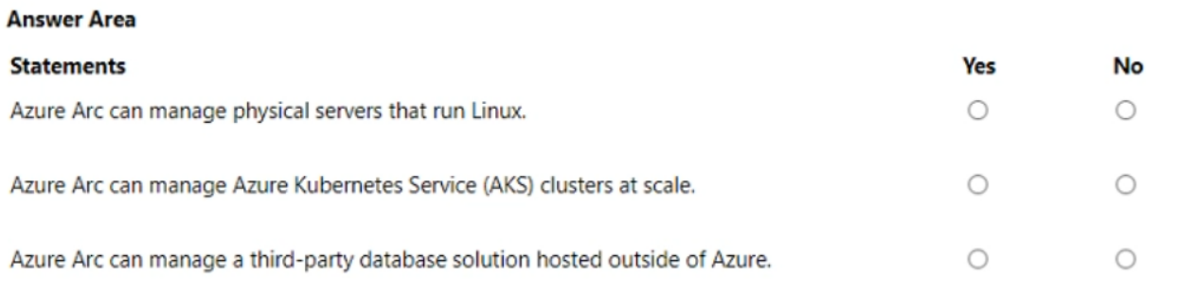

Answer:

The answer is YYY

Yes, Azure Arc can manage physical servers that run Linux. It extends Azure management capabilities to on-premises and multi-cloud environments, allowing you to manage servers, whether they are in Azure or outside of Azure.

Yes, Azure Arc can manage Azure Kubernetes Service (AKS) clusters at scale. It allows you to extend Azure management to AKS clusters that are not running in Azure, providing centralized management for Kubernetes clusters across different environments.

Yes, Azure Arc can manage a third-party database solution hosted outside of Azure. It allows you to bring databases running on physical servers or in other cloud environments under Azure management using Azure Arc.

## 100.

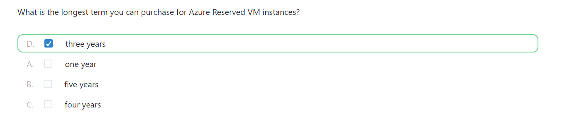

## 101. Storage Access tiers

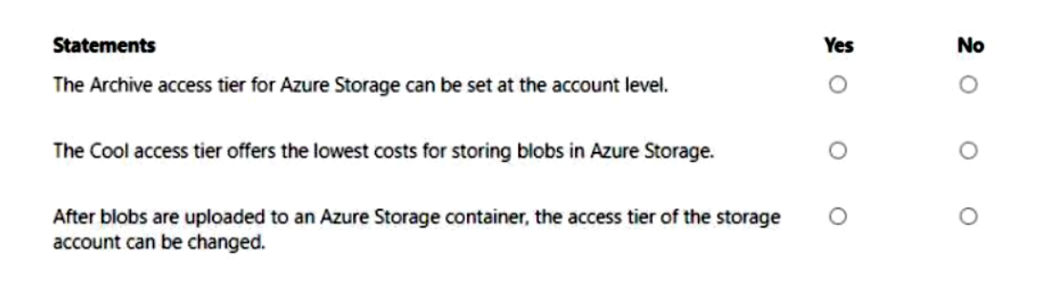

Answer:

NNY

Archive access tier cannot be set at the account level in Azure Storage. The Archive tier is a storage class that can be set at the blob level within a storage account, but not at the account level.

Below we can see that only hot and cool access tiers are present at the account level.

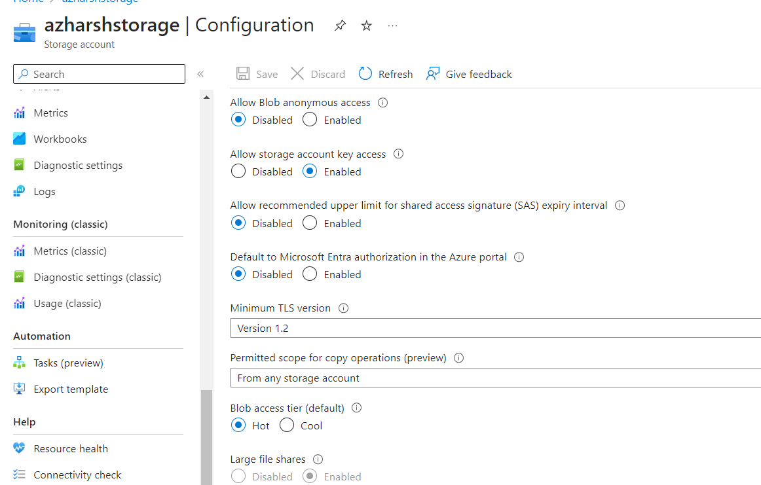

The Archive access tier in Azure Storage offers the lowest cost for storing blobs among the three access tiers: Hot, Cool, and Archive.

The Archive access tier is designed for data that is rarely accessed and can tolerate several hours of retrieval latency. It has the lowest storage costs among the three access tiers, but higher data retrieval costs and longer retrieval times. This makes it a good choice for data that is seldom accessed and can tolerate longer retrieval times.

The access tier of a storage account can be changed at any time, and it applies to all blobs within the account that have not had their access tier explicitly set. Changing the access tier of a storage account affects all blobs that do not have an explicit access tier set, including those that were uploaded prior to the change

## 102. Azure Advisor

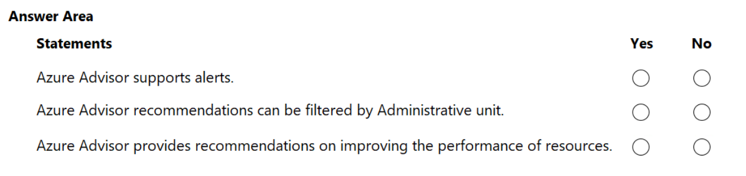

Answer:

YNY

No, because Azure Advisor allows you to filter recommendations based on various criteria such as subscription, resource group, resource type, and recommendation category (cost, security, reliability, operational excellence, and performance), but not by administrative units.

## 103. Azure VM

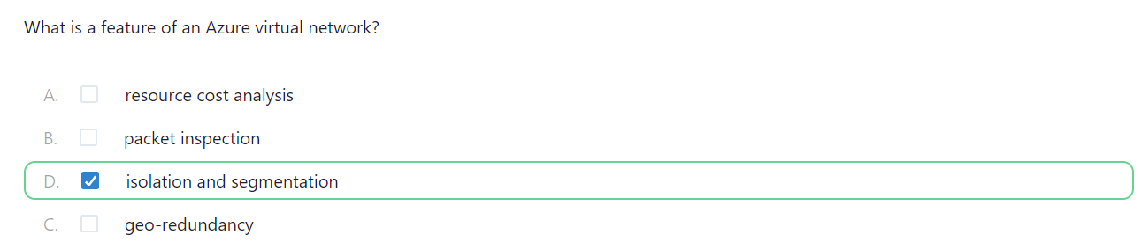

Answer: Isolation and segmentation

Isolation because, Azure is a multi-tenant environment, meaning multiple customers share the same physical hardware. Isolation ensures that VMs from different customers cannot interfere with each other. Azure uses a hypervisor to create and manage VMs. Each VM runs on isolated virtual hardware, ensuring that processes and data in one VM cannot access or affect another VM.

VMs can be placed in isolated virtual networks (VNets), preventing network traffic from being visible to other VNets.

Isolating development and testing environments from production environments prevents unintentional disruptions and maintains security.

Segmentation because, Segmentation allows you to deploy different tiers of an application (e.g., web, application, database) in separate subnets, enhancing security and performance.

## 104. Azure Policy

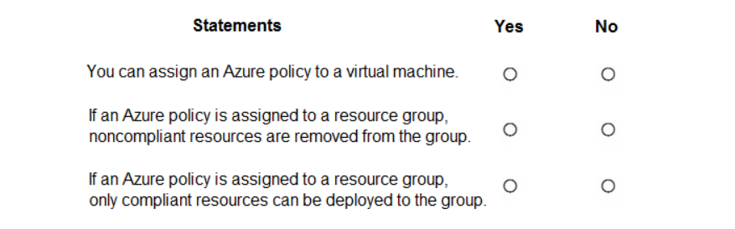

Answer:

YNY

## 105.

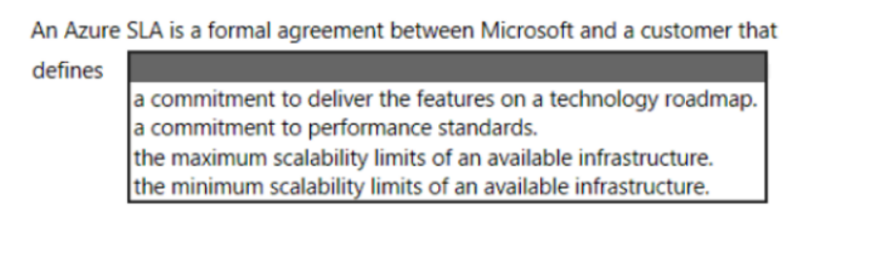

Answer: A commitment to performance standards

## 106. Storage

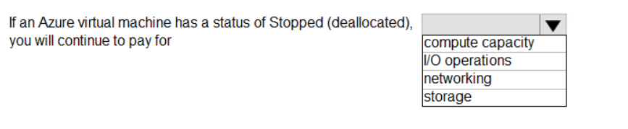

Answer: storage

Azure doesn't charge for the VM core hours while it is Stopped (Deallocated). However, you continue to accrue charges for the Azure storage needed for the VM's OS disk and any attached data disks.

## 107. Storage

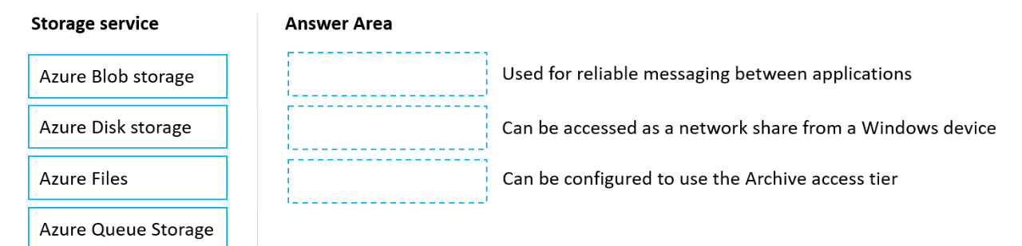

Answer:

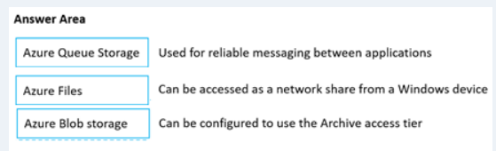

## 108.

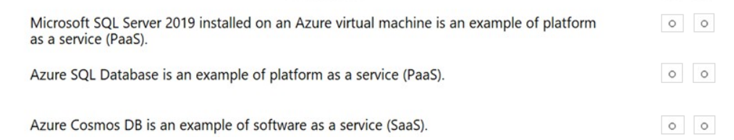

Answer:

NYN

## 109.

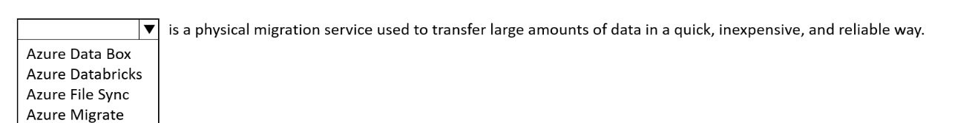

Answer: Azure Data Box

## 120.

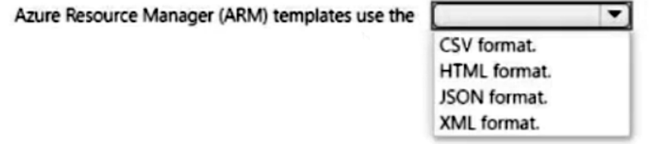

Answer: JSON format

## 121.

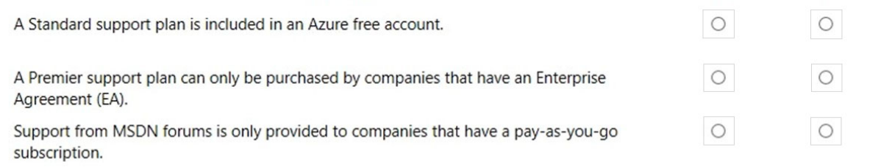

Answer: NYN

No - An Azure free account comes with a 'basic' support plan, not a 'standard' support plan.

No - Users with any type of Azure subscription (pay-as-you-go, Enterprise Agreement, Microsoft Customer Agreement etc.) can get support from the MSDN forums.

## 122. Azure Defender

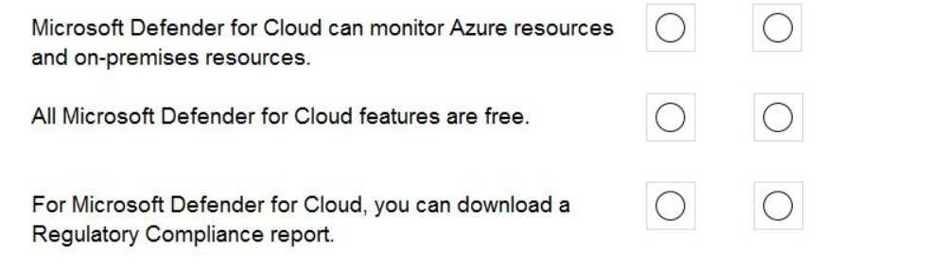

Answer:

Yes-No-Yes

## 123.

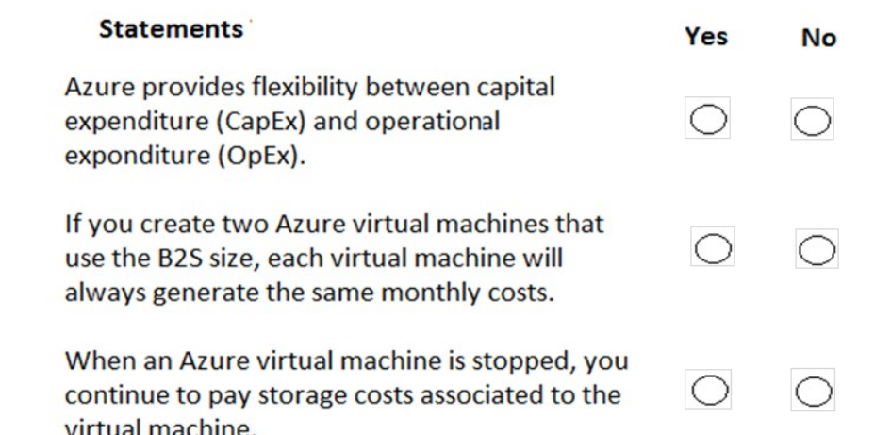

Answer:

Yes-No-Yes

## 124.

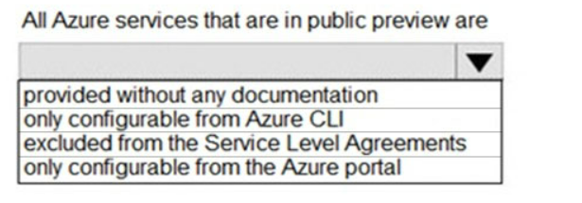

Answer: Excluded from the Service level agreements

## 125.

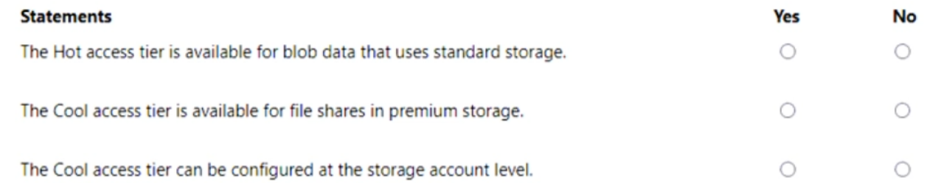

Answer:

Y-N-Y

## 126. Composite SLA

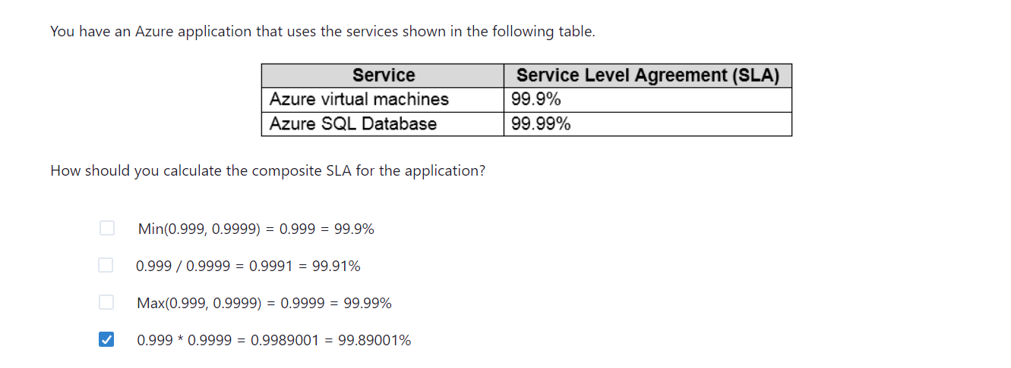

## 127.

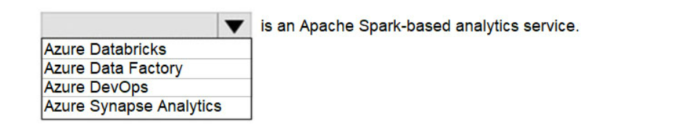

Answer: Azure Databricks

## 128.

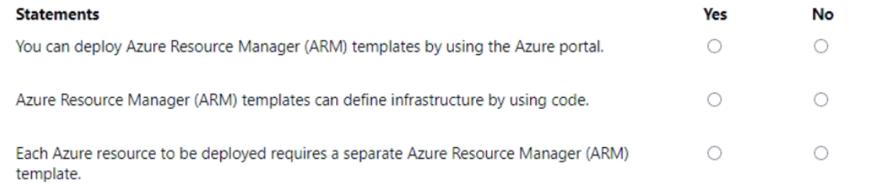

Answer: YYN

## 129.

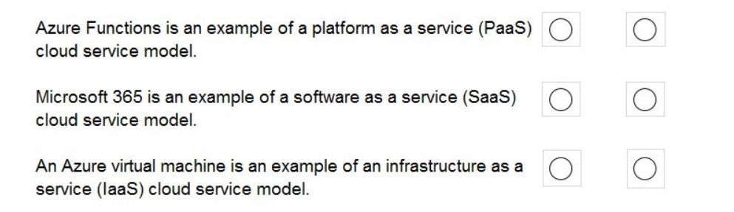

Answer: YYY

## 130.

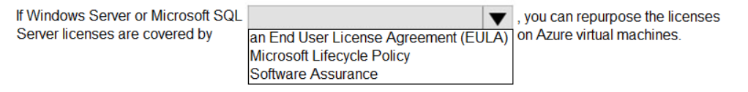

Answer:

Software assurance.

The Azure Hybrid Benefit allows you to use your on-premises Windows Server and SQL Server licenses with Software Assurance to save on Azure Virtual Machines.

## 131.

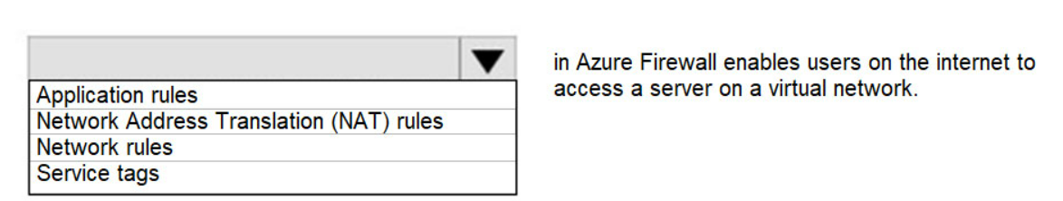

Answer:

NAT rules

## 132. Preview

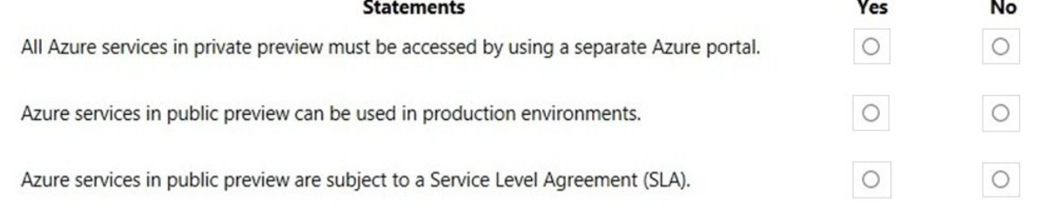

Answer: No-Yes-No

Public Preview means that the service is in public beta and can be tried out by anyone with an Azure subscription. Services in public preview are often offered at a discount price.

Box 1: No - Services in private preview can be viewed in the regular Azure portal. However, you need to be signed up for the feature in private preview before you can view it. Access to private preview features is usually by invitation only.

Box 2: Yes - You can use services in public preview in production environments. However, you should be aware that the service may have faults, is not subject to an SLA and may be withdrawn without notice.

Box 3: No - Public previews are excluded from SLAs and in some cases, no support is offered.

## 133. ExpressRoutes

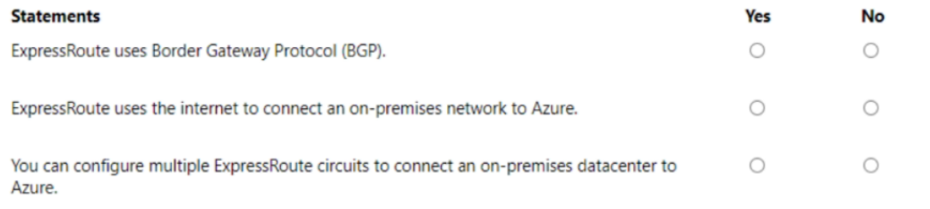

Answer: Y-N-Y

## 134.

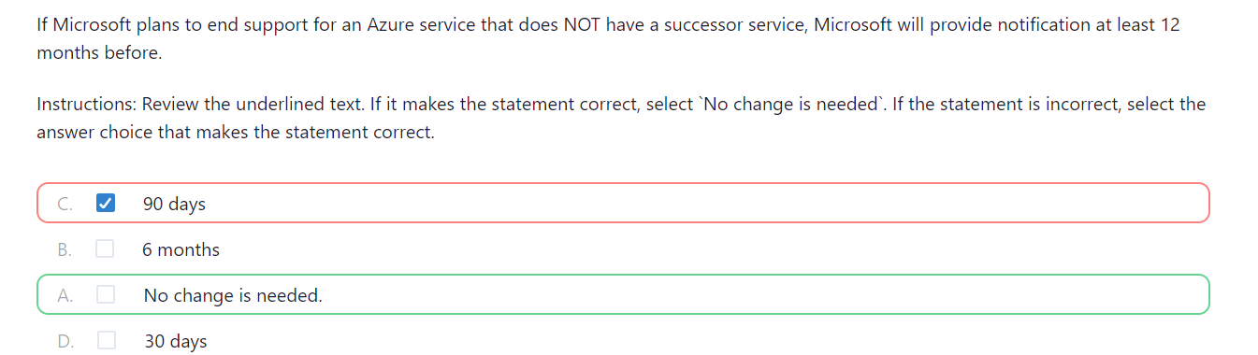

## 135. Azure Advisor

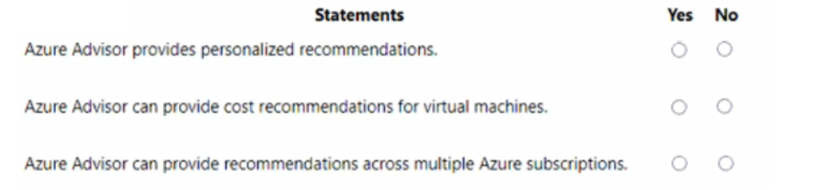

Answer: YYY

## 136. Azure Cloud Shell

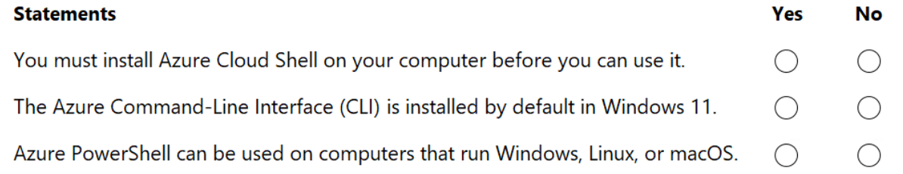

Answer: NNY

## 137. VMs

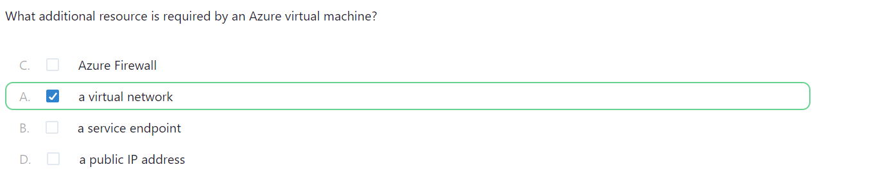

Answer: Every VM in Azure must be deployed within a Virtual Network. The VNet provides networking capabilities and isolation for your VM. It allows your VM to communicate with other resources securely within the same network.

## 138. Resource lock

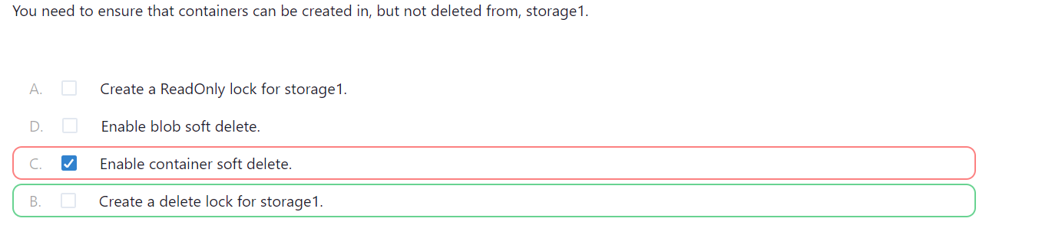

## 139. Azure support

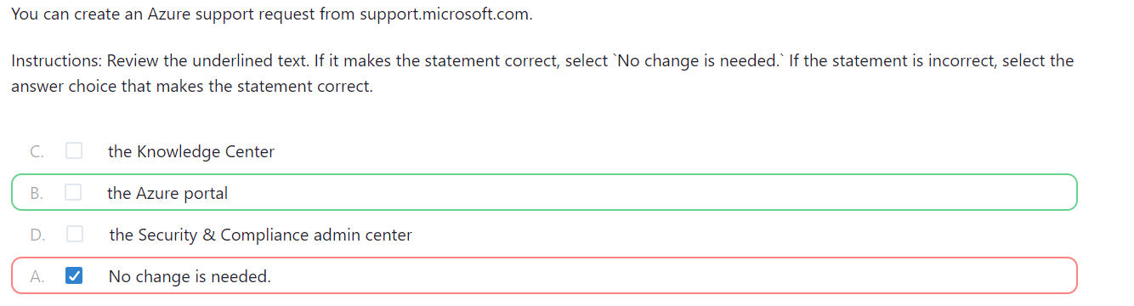

## 140. Scaling

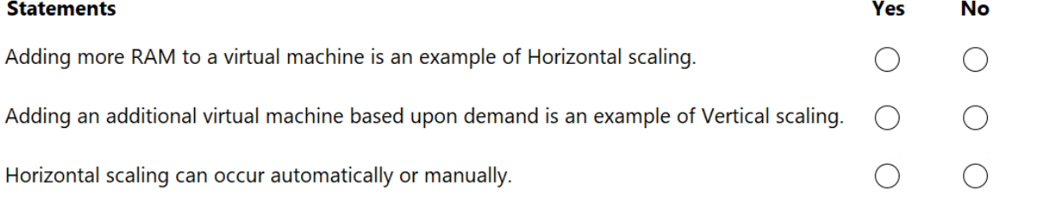

Answer: N-N-Y

## 141. Tags

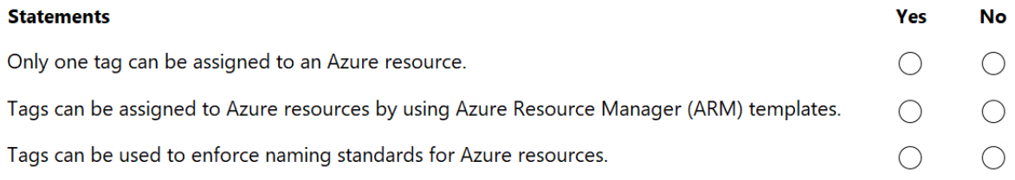

Answer: N-Y-N

## 142. Azure AD

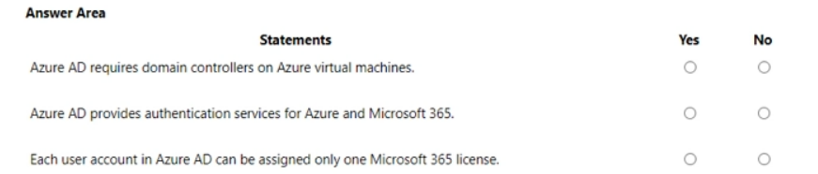

Answer: N-Y-N

## 143.

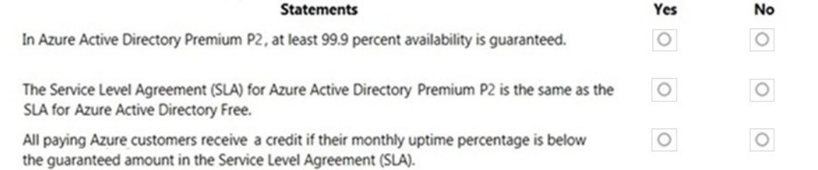

Answer: Y-N-Y

Box 1: Yes - Microsoft guarantee at least 99.9% availability of the Azure Active Directory Premium edition services. The services are considered available in the following scenarios: Users are able to login to the service, login to the Access Panel, access applications on the Access Panel and reset passwords. IT administrators are able to create, read, write and delete entries in the directory or provision or de-provision users to applications in the directory.

Box 2: No - No SLA is provided for the Free tier of Azure Active Directory.

Box 3: Yes - You can claim credit if the availability falls below the SLA. The amount of credit depends on the availability. For example: You can claim 25% credit if the availability is less than 99.9%, 50% credit for less than 99% and 100% for less than 95% availability.

## 144.

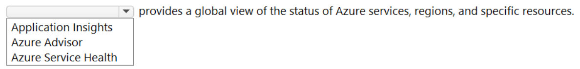

Answer: Azure Service Health

## 145.

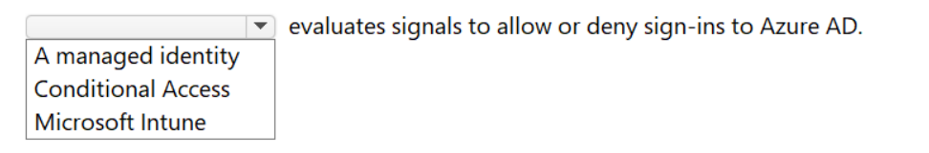

Answer: Conditional Access

## 146.

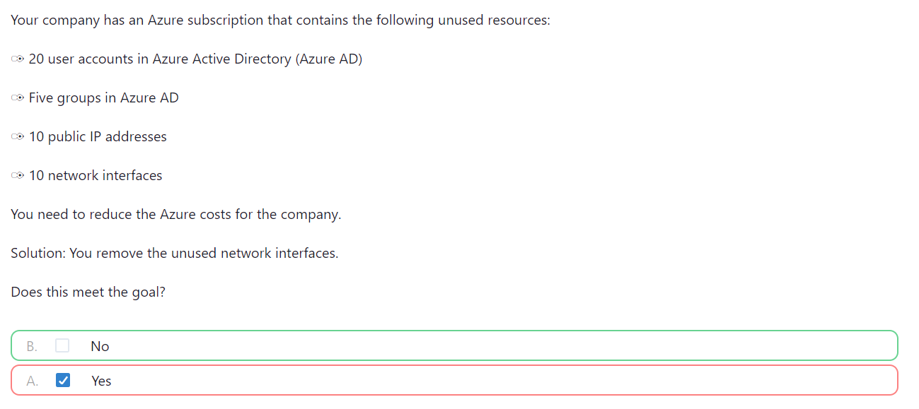

Answer: removing public ip addresses will help cut the cost.

NIC are free and they come with vnet and vnets are free.

## 147.

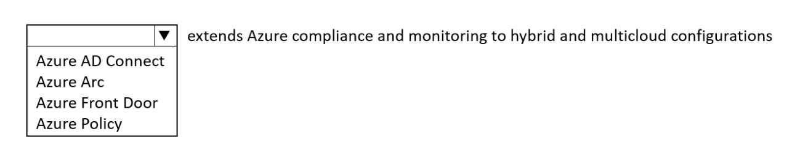

Answer: Azure Arc

## 148. VNets

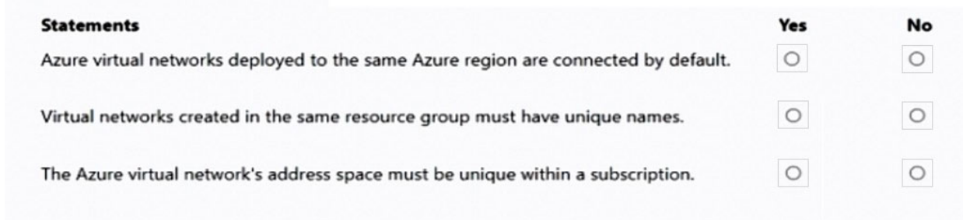

Answer:

N-Y-N

Y – Vnet name must be unique in same resource group but can be same with in subscription.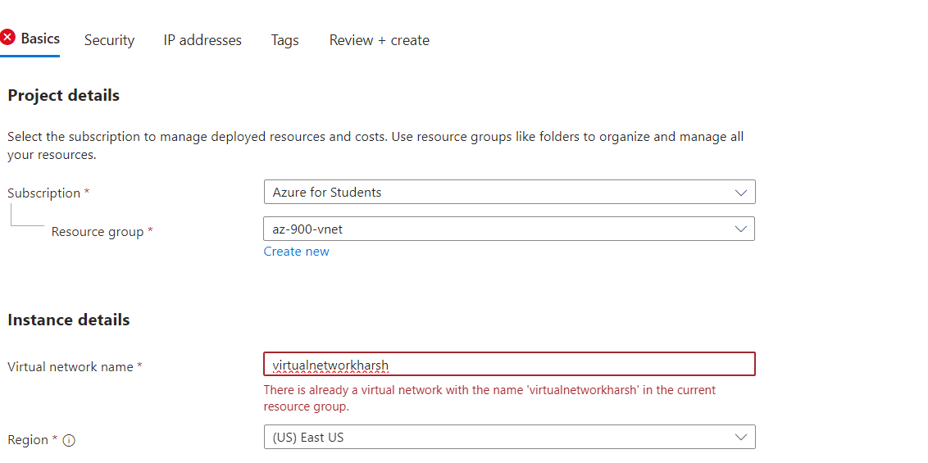

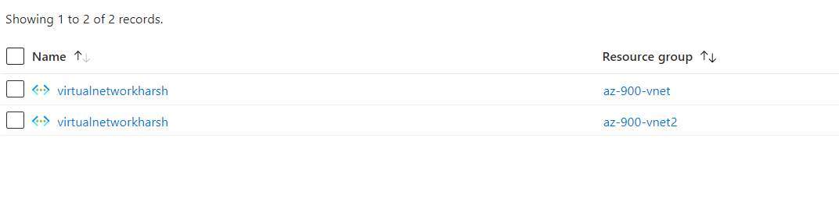

N- VNet address space can be same with the subscription and also same resource group.

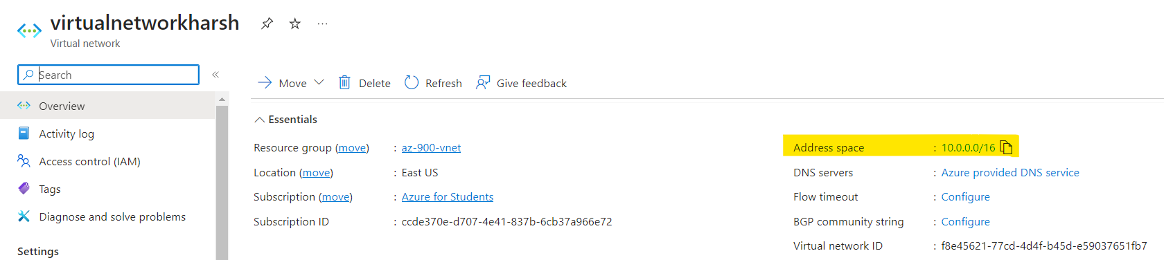

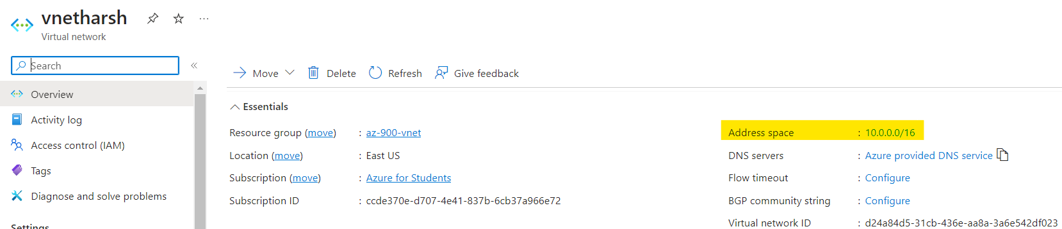

## 149.

On which layer is ddos protection applied in azure?

* Application layer
* Network layer
* Perimeter layer

Answer:

Perimeter Layer

## 150.

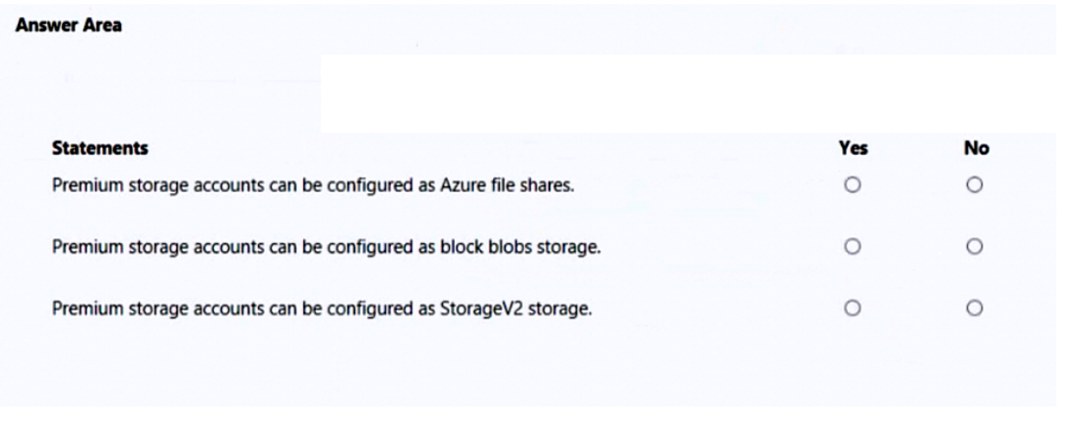

Answer:

Y-Y-N

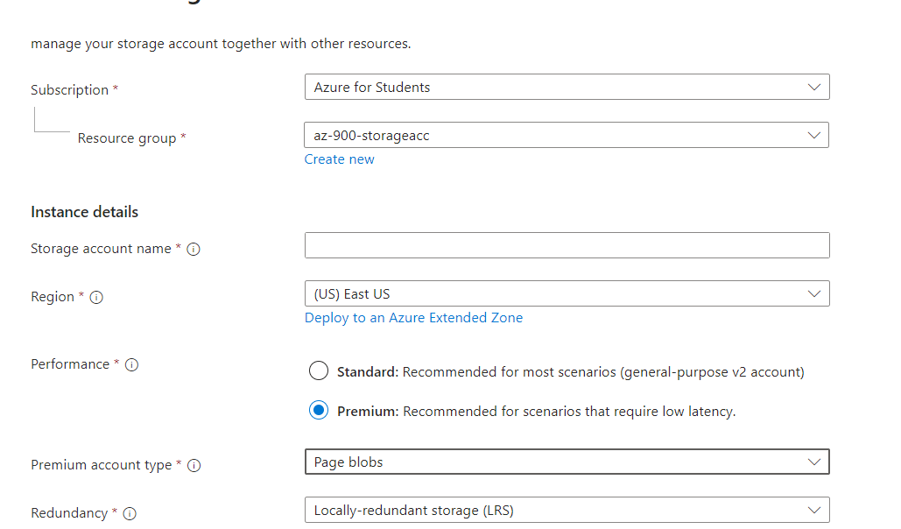

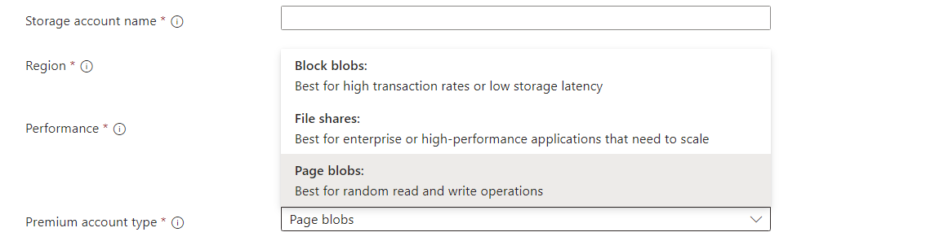

## 151. Azure Monitor

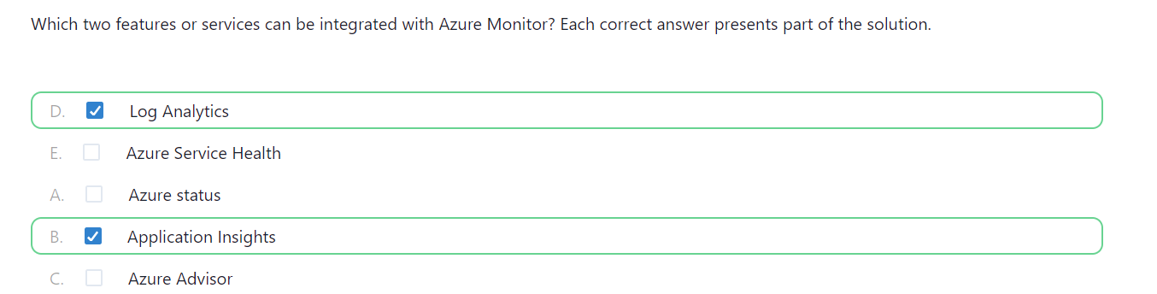

## 152.

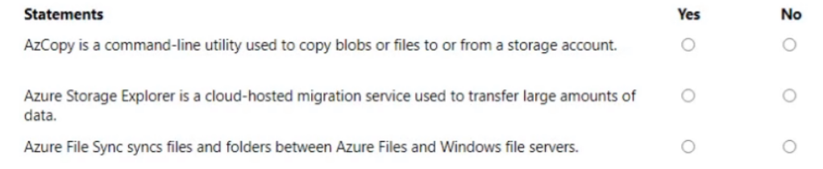

Answer: Y-N-Y

## 153.

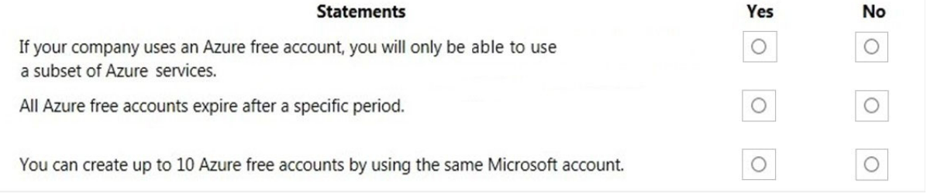

Answer: Y-Y-N

## 154.

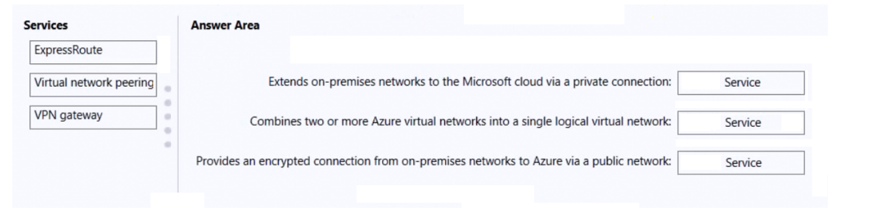

Answer: 1. ExpressRoute 2. VNet Peering 3. VPN gateway

## 155.

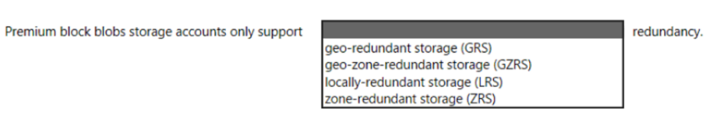

Answer: LRS and ZRS

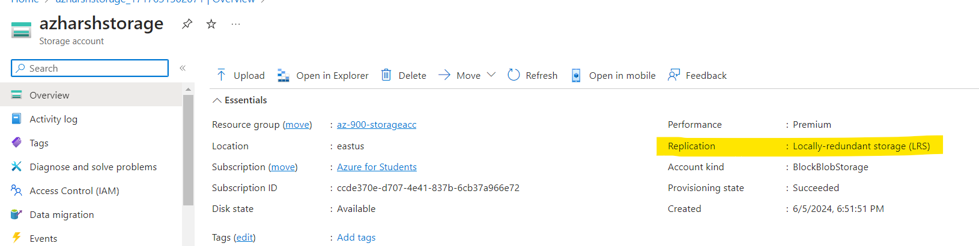

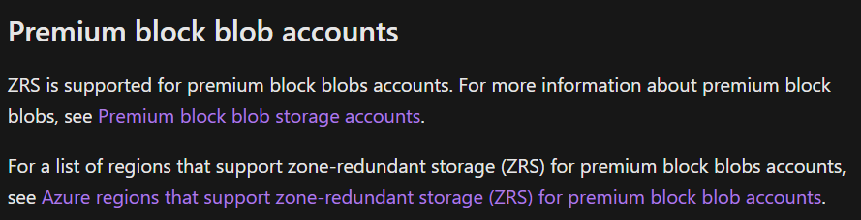

## 156. TCO

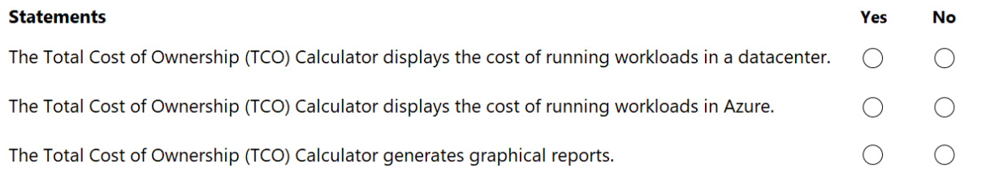

Answer: Y-Y-Y

## 157.

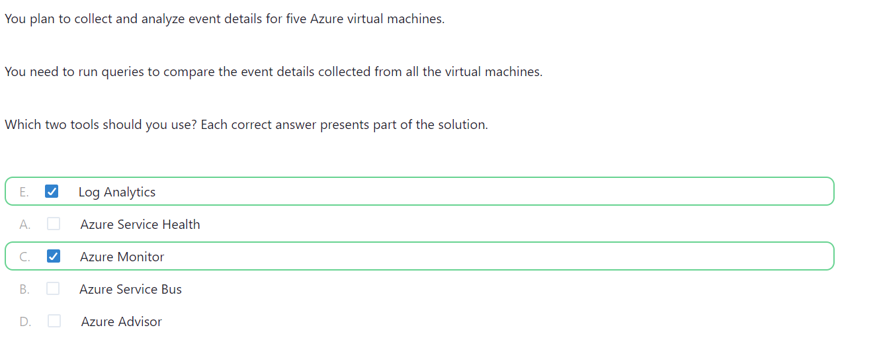

## 158.

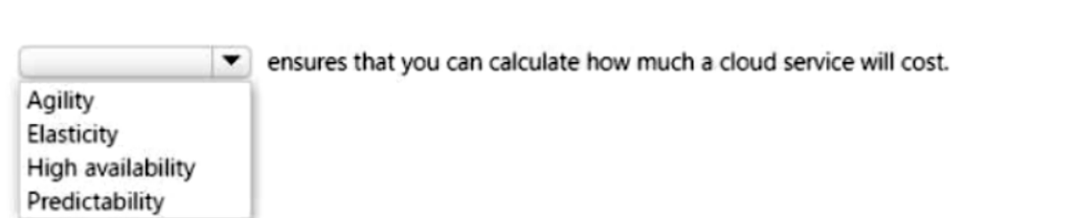

Answer: Predictability

## 159.

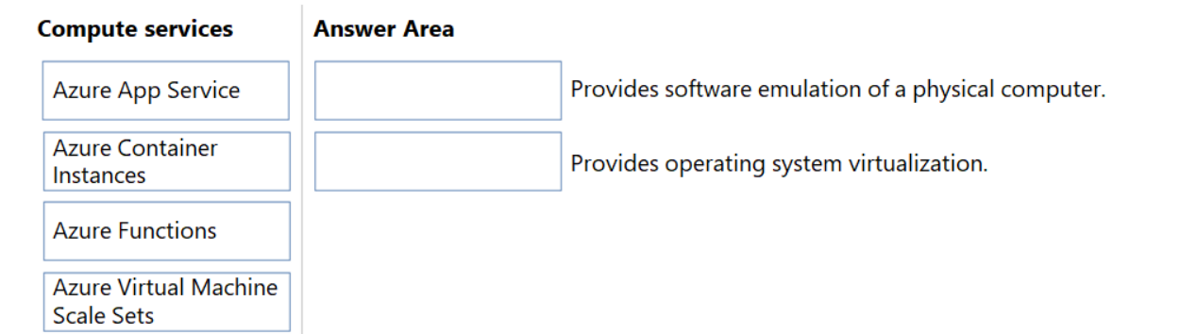

Answer: 1. Azure Container Instances 2. Azure VM Scale Sets

## 160. Spot VM

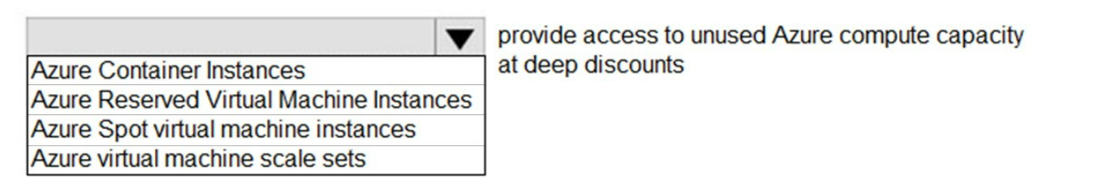

Answer: Spot VM

## 161.

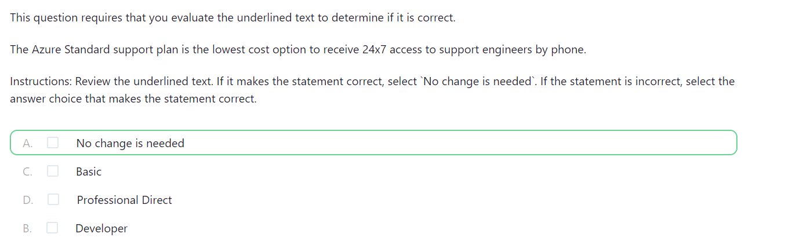

Answer:

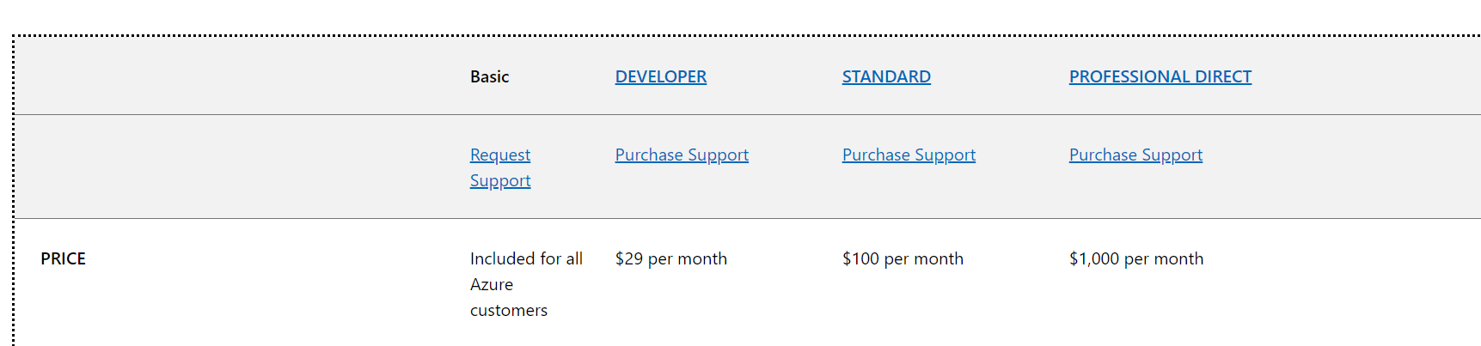

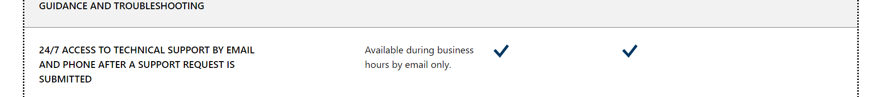

## 162.

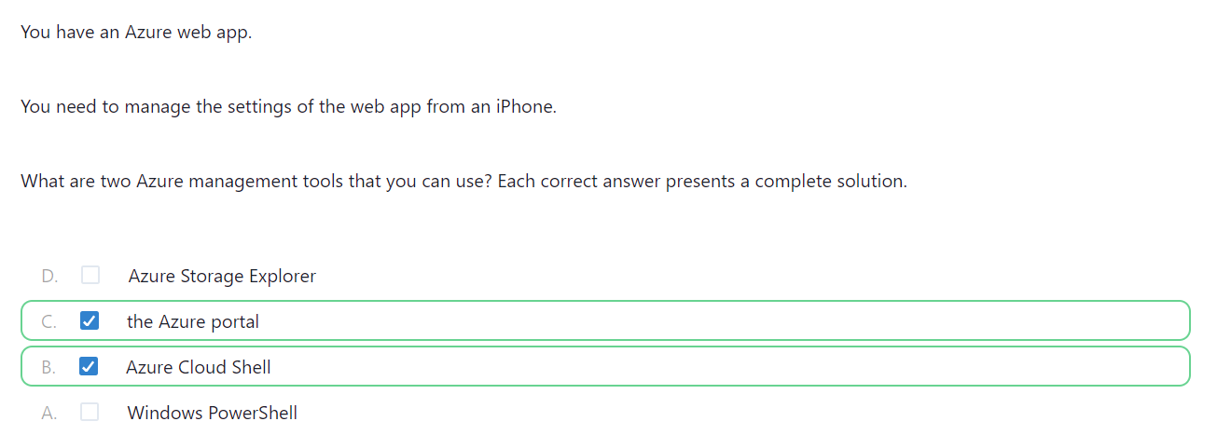

## 163.

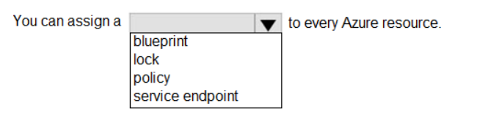

Answer: lock

## 165.

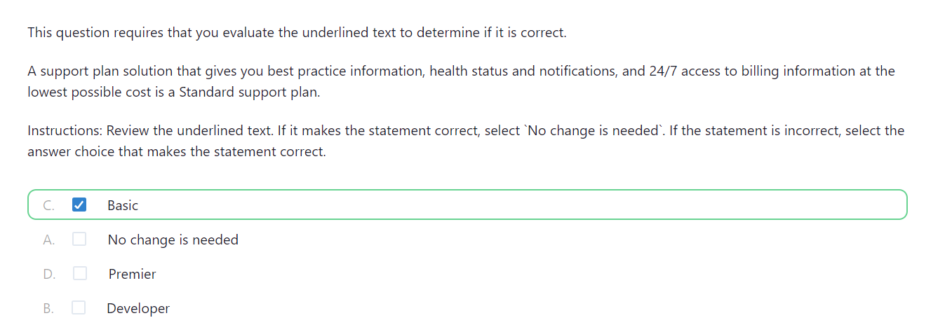

Reference: <https://azure.microsoft.com/en-us/support/plans/>

## 166.

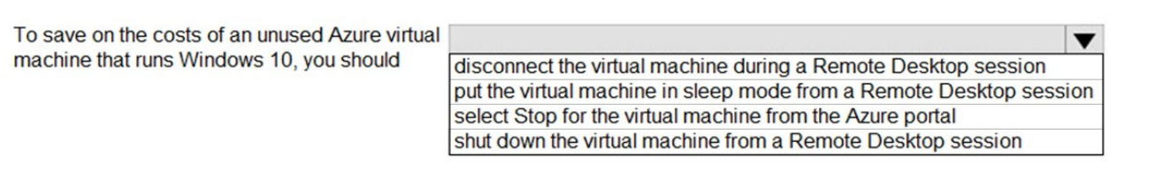

Answer: Stop

## 167.

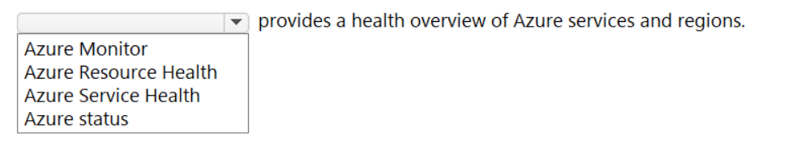

Answer: Azure Service Health

## 168.

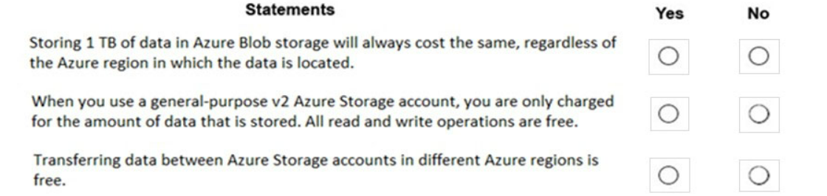

Answer:

Box 1: No -

The price of Azure storage varies by region. If you use the Azure storage pricing page, you can select different regions and see how the price changes per region.

Box 2: No -

You are charged for read and write operations in general-purpose v2 storage accounts.

Box 3: No -

You would be charge for the read operations of the source storage account and write operations in the destination storage account.

## 169. Azure Virtual Desktop

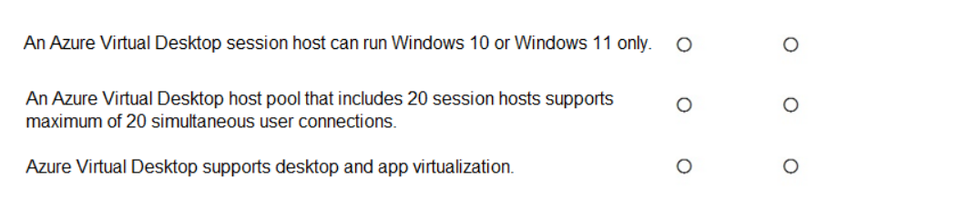

Answer: N-N-Y

## 170.

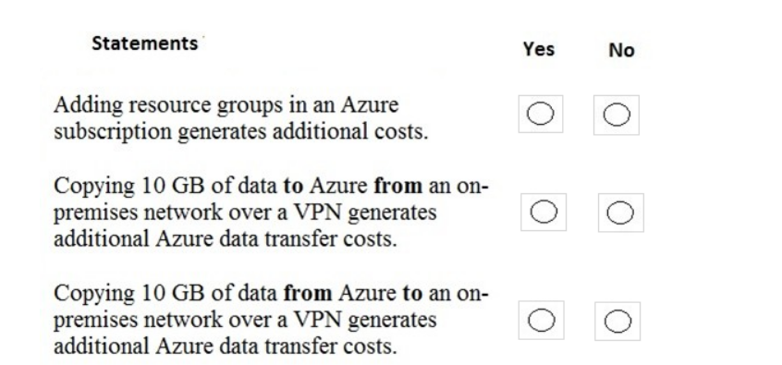

Answer:

Box 1: No -

Resource groups are logical containers for Azure resources. You do not pay for resource groups.

Box 2: No -

Data ingress over a VPN is data 'coming in' to Azure over the VPN. You are not charged data transfer costs for data ingress.

Box 3: Yes -

Data egress over a VPN is data 'going out' of Azure over the VPN. You are charged for data egress.

## 171.

